A Project Report on
NEUROVISION: UNIFIED MULTIMODAL FEATURE FOR ROBUST DISEASE DETECTION IN NEURODEGENERATION
Submitted to
JAWAHARLAL NEHRU TECHNOLOGICAL UNIVERSITY ANANTAPUR,
ANANTHAPURAMU
In Partial Fulfillment of the Requirements for the Award of the Degree of

BACHELOR OF TECHNOLOGY
in

COMPUTER SCIENCE AND ENGINEERING (ARTIFICIAL INTELLIGENCE)
Submitted By

Tejasree Kothapalli | - | 22691A31H2
Vuppanelli Yasaswini | - | 22691A31J4
Yuvaratna Teja.C | - | 23695A3119
Shanmuka Sai.B | - | 22691A31F4
Under the Guidance of
Dr. Vamsi Bandi, M. Tech., Ph.D.
Assistant Professor
Department of Computer Science and Engineering (Artificial Intelligence)



MADANAPALLE INSTITUTE OF TECHNOLOGY & SCIENCE (UGC – AUTONOMOUS)
(Affiliated to JNTUA, Ananthapuramu) Accredited by NBA, Approved by AICTE, New Delhi)
AN ISO 21001 : 2018 EMOS Certified Institution
P. B. No: 14, Angallu, Madanapalle – 517325
2022-2026 Batch (AY: 2025-2026)



DEPARTMENT OF COMPUTER SCIENCE AND ENGINEERING

(ARTIFICIAL INTELLIGENCE)

BONAFIDE CERTIFICATE
This is to certify that the project work entitled “NEUROVISION: UNIFIED MULTIMODAL FEATURE FOR ROBUST DISEASE DETECTION IN NEURODEGENERATION” is a bonafide work carried out by

Tejasree Kothapalli | - | 22691A31H2
Vuppanelli Yasaswini | - | 22691A31J4
Yuvaratna Teja.C | - | 23695A3119
Shanmuka Sai.B | - | 22691A31F4

Submitted in partial fulfillment of the requirements for the award of degree Bachelor of Technology in the stream of Computer Science and Engineering (Artificial Intelligence) in Madanapalle Institute of Technology & Science, Madanapalle, affiliated to Jawaharlal Nehru Technological University Anantapur, Ananthapuramu during the academic year 2025-2026.

Guide Head of the Department
Dr. Vamsi Bandi, M. Tech., Ph.D. Prof. R. Kalpana, M.E, Ph.D.
Assistant Professor Professor & Head
Department of CSE(AI) Department of CSE(AI)

Submitted for the University examination held on:

Internal Examiner External Examiner
Date: Date:

ACKNOWLEDGEMENTS

We sincerely thank the Management of Madanapalle Institute of Technology & Science for providing excellent infrastructure and lab facilities that helped me to complete this project.
We sincerely thank Dr. P. Ramanathan, Principal for guiding and providing facilities for the successful completion of our project at Madanapalle Institute of Technology & Science, Madanapalle.
We express our deep sense of gratitude to Dr. R. Kalpana, Professor & Head, Department of CSE(AI) for her continuous support in making necessary arrangements for the successful completion of the project.
We express our deep gratitude to my guide, Dr. Vamsi Bandi, Asst. Professor, Department of CSE(AI) for his guidance and encouragement that helped us to complete this project.
We express our deep gratitude to Dr. Vamsi Bandi and Dr. G. Jenifa, Project Coordinator(s), Department of CSE(AI) for their valuable guidance and encouragement that helped us to complete this project.
We also wish to place on record my gratefulness to other Faculty members of Department of CSE(AI) and also to our friends and our parents for their help and cooperation during our project work.


MADANAPALLE INSTITUTE OF TECHNOLOGY & SCIENCE
(UGC-AUTONOMOUS INSTITUTION)
Affiliated to JNTUA, Ananthapuramu &Approved by AICTE, NewDelhi
NAAC Accredited with A+ Grade, NIRF India Rankings 2025-Band: 201-300 (Engg.)
NBA Accredited -B.Tech. (CIVIL, CSE, ECE, EEE, MECH, CST), MBA & MCA
www.mits.ac.in

RECOGNISED RESEARCH CENTER

Plagiarism Verification Certificate

This is to certify that the B. Tech Project report titled, “Neurovision: Unified Multimodal Feature For Robust Disease Detection In Neurodegeneration” submitted by TEJASREE KOTHAPALLI (22691A31H2), VUPPANELLI YASASWINI (22691A31J3), YUVARATHNA TEJA.C (23695A3119),SHANMUKA SAI.B (22691A31F4) has been evaluated using Anti- Plagiarism Software, TURNITIN and based on the analysis report generated by the software, the report’s similarity index is found to be 18%.

The following is the TURNITIN report for the project report consisting of 91 pages.

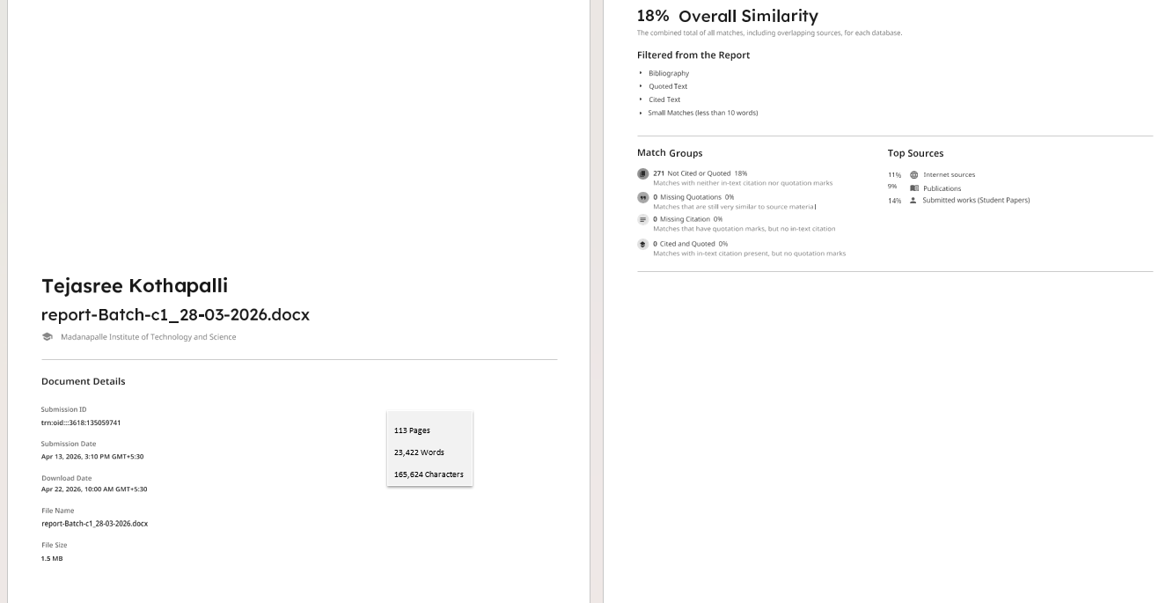









DECLARATION

We hereby declare that the results embodied in this project “Neurovision: Unified Multimodal Feature for Robust Disease Detection in Neurodegeneration” by us under the guidance of Dr. Vamsi Bandi, Asst. Professor, Department of Computer Science and Engineering (Artificial Intelligence) in partial fulfillment of the award of Bachelor of Technology in Computer Science and Engineering (Artificial Intelligence) from Jawaharlal Nehru Technological University Anantapur, Ananthapuramu. The content of this report is not submitted to any other University/Institute for award of any other degree.

Date :
Place : Madanapalle

PROJECT ASSOCIATES:

TEJASREE KOTHAPALLI
VUPPANELLI YASASWINI
YUVARATNA TEJA.C
SHANMUKA SAI.B

I certify that the above statement made by the students is correct to the best of my knowledge.

Date: Guide

Dr. Vamsi Bandi

INDEX

S.NO | TOPIC | PAGE NO.
1. | INTRODUCTION
 | 1.1 Introduction to Neurodegenerative diseases | 1
 | 1.2 Motivation | 2
 | 1.3 Problem Definition | 2
 | 1.4 Benefits of Early Detection of Neurodegenerative diseases | 2
 | 1.5 Role of Machine Learning and Deep Learning in Early Detection | 3
 | 1.6 Objectives of the Project | 4
 | 1.7 Statistics of Neuro degenerative diseases in Worldwide Vs India | 4
 | 1.8 Limitations of the Project | 6
 | 1.9 Organization of Documentation | 7
2. | LITERATURE SURVEY
 | 2.1 Introduction | 8
 | 2.2 Existing System | 8
 | 2.3 Disadvantages of Existing System | 15
 | 2.4 Proposed System | 15
 | 2.5 Advantages of the Proposed System | 18
3. | ANALYSIS
 | 3.1 Introduction | 20
 | 3.2 Software Requirement Specification | 20
4. | DESIGN
 | 4.1 Introduction | 26
 | 4.2 UML Diagrams | 27
 | 4.3 Module Design and Organization | 30
 | 4.4 Summary | 30
5. | IMPLEMENTATION AND RESULTS
 | 5.1 Introduction | 31
 | 5.2 Implementation of Key Functions | 32
 | 5.3 Method of Implementation | 35
 | 5.4 Output Screens and Result Analysis | 73
 | 5.5 Summary | 76
6. | TESTING AND VALIDATION
 | 6.1 Introduction | 77
 | 6.2 Design of Test Cases and Scenarios | 79
 | 6.3 Validation Testing | 82
 | 6.4 ROC-AUC Analysis of Random Forest | 83
 | 6.5 Prediction Outcomes | 84
 | 6.6 Summary | 88
7. | CONCLUSION
 | 7.1 Conclusion | 89
 | 7.2 Future Enhancements | 89
 | REFERENCES | 90

ABSTRACT

Accurate detection of neurodegenerative diseases from brain magnetic resonance imaging (MRI) remains challenging due to multimodal variability, feature redundancy, and complex disease patterns. This work presents Neurovision, a unified multimodal framework for MRI-based neurological disease detection using T1-weighted, T2-weighted, FLAIR, and related MRI sequences. The input brain MRI images are preprocessed through intensity normalization, spatial resizing, and data balancing to ensure consistent and high-quality inputs. A deep convolutional neural network is employed to extract discriminative features that capture both local and global disease characteristics. Particle Swarm Optimization (PSO) is integrated for optimal feature selection to reduce redundancy and enhance representation quality. The framework is evaluated under intra-dataset and cross-dataset settings to assess robustness and generalization across MRI modalities. Additionally, ROI-aware feature fusion is applied to combine local-based and global-based features into a unified representation. Experimental results demonstrated that the proposed approach achieved an accuracy of 91% in training and 89% of validation accuracy and got 91% of testing accuracy.
Keywords: Neurovision, Neurodegeneration, Feature Extraction, Deep Learning, PSO, Feature Selection, ROI Fusion

LIST OF FIGURES

Figures | Title | Page
1.1 | Neurodegenerative diseases | 1
2.1 | Sample images of MCND dataset | 16
2.2 | Proposed Architecture for neurodegenerative diseases | 16
4.1 | State Chart Diagram | 27
4.2 | Sequence Diagram | 28
4.3 | Use Case Diagram | 29
4.4 | Collaborative Diagram | 29
5.1 | Confusion matrix of random forest | 51
5.2 | Training and Validation AUC of random forest | 53
5.3 | Validation on MCND dataset | 57
5.4 | Normal MRI predictions with confidence | 58
5.5 | Multiple sclerosis MRI predictions with confidence | 59
5.6 | AD_MildDemented MRI predictions with confidence | 59
5.7 | AD_ModerateDemented MRI predictions with confidence | 59
5.8 | AD_VeryMildDemented MRI predictions with confidence | 60
5.9 | BT_glioma MRI predictions with confidence | 60
5.10 | BT_Meningioma MRI predictions with confidence | 60
5.11 | BT_Pituitary MRI predictions with confidence | 61
5.12 | Disease predictions on Cross dataset MRI images | 69
5.13 | AD_MildDemented Predictions on Cross dataset with Confidence | 70
5.14 | Normal Predictions on Cross dataset with Confidence | 71
5.15 | Multiple sclerosis Predictions on Cross dataset with Confidence | 71
5.16 | BT_Glioma Predictions on Cross dataset with Confidence | 71
5.17 | BT_Meningioma Predictions on Cross dataset with Confidence | 72
5.18 | BT_Pituitary Predictions on Cross dataset with Confidence | 72
5.19 | AD_ModerateDemented Predictions on Cross dataset with Confidence | 72
5.20 | AD_VeryMildDemented Predictions on Cross dataset with Confidence | 73
5.21 | Home page of neurovision webiste | 73
5.22 | Image upload interface of neurovision web application | 74
5.23 | MRI image result-AD_ModerateDemented Classification | 74
5.24 | Brain Tumor (Pituitary)prediction with confidence score | 75
5.25 | Web interface displaying a multiple sclerosis prediction for uploaded MRI image | 75
6.1 | ROC-AUC of random forest | 83

LIST OF TABLES

Tables | Title | Page
1.1 | Diseases in India | 5
1.2 | Alzheimer’s Disease in India and it’s Mortality rate | 5
1.3 | Multiple Sclerosis | 6
1.4 | Brain Stroke | 6
2.1 | Summary of existing works | 11
2.2 | Summary of dataset | 15
6.1 | Test Case for model training | 79
6.2 | Test Case for model preprocessing | 79
6.3 | Test Case for model preprocessing and model training | 79
6.4 | Test Case for model fitting | 80
6.5 | Test Case for feature optimization | 80
6.6 | Test Case for Cross-dataset evaluation | 80
6.7 | Test Case for cross dataset processing | 81
6.8 | Test Case for model evaluation | 81
6.9 | Testcase for UI functionality | 81
6.10 | Prediction outcomes | 82
6.11 | Strengths and Weaknesses of ML models | 85
6.12 | MCND dataset validation | 86
6.13 | Cross dataset validation | 87

CHAPTER-1 INTRODUCTION

CHAPTER-1 INTRODUCTION

INTRODUCTION TO NEURODEGENERATIVE DISEASES
Neurodegenerative diseases are a group of chronic and progressive disorders characterized by the gradual degeneration and loss of structure or function of neurons in the brain and spinal cord. These conditions primarily affect cognitive, motor, and behavioural functions, leading to significant impairment in daily activities and overall quality of life. They often develop slowly and may remain undetected in the early stages, making timely diagnosis difficult. Genetic, environmental, and lifestyle factors are believed to contribute to the onset and progression of these disorders. Since neuronal damage is largely irreversible, most neurodegenerative diseases worsen over time and currently lack a definitive cure. Common examples include Alzheimer’s disease, Parkinson’s disease, Multiple Sclerosis, Huntington’s disease, and certain types of brain tumors. Among these, Alzheimer’s disease is the leading cause of dementia worldwide, while Multiple Sclerosis is a major contributor to neurological disability among young adults.
The increasing global life expectancy has contributed to a rapid rise in the prevalence of neurodegenerative disorders, making them a major public health concern. This burden is particularly evident in developing countries like India, where early diagnosis and access to advanced healthcare facilities remain challenging. Delayed detection often results in severe neuronal damage and reduced treatment effectiveness. Medical imaging techniques, especially Magnetic Resonance Imaging (MRI), play a crucial role in identifying structural and functional abnormalities such as brain atrophy, lesions, tumors, and demyelination. However, traditional diagnostic approaches rely heavily on manual interpretation, which may overlook subtle and complex patterns.

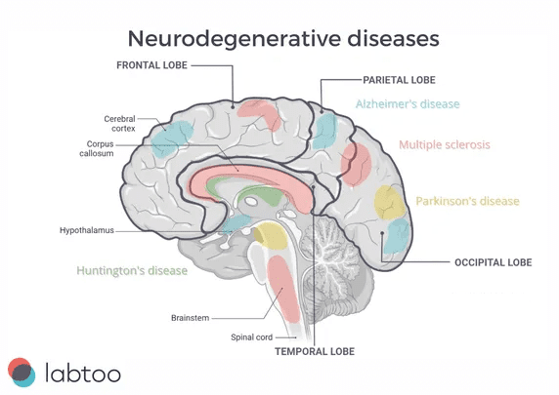
Fig 1.1 Neurodegenerative Diseases
Fig 1.1 presents a visual representation of brain regions affected by various neurodegenerative diseases. It highlights how different disorders target specific lobes and internal structures, providing a clearer understanding of their spatial impact and supporting the need for advanced diagnostic methods.

MOTIVATION
Neurodegenerative conditions like Alzheimer’s disease, Multiple Sclerosis, and brain tumors highlight the increasing demand for enhanced and thorough diagnostic methods. Conventional single-modality MRI assessments, although clinically useful, frequently do not detect subtle structural alterations, intricate disease patterns, and early-stage irregularities throughout the brain.
Conversely, cohesive deep learning systems that combine multimodal MRI data facilitate a more comprehensive understanding of neurodegeneration by encompassing both localized region-specific traits and overall brain attributes. Utilizing extensive neuroimaging datasets alongside enhanced feature selection and ROI-sensitive fusion facilitates the creation of resilient and widely applicable models that can differentiate neurological disorders with improved precision. In the end, these advanced diagnostic systems facilitate timely interventions, decrease diagnostic ambiguity, enhance clinical decision-making, and help reduce long-term healthcare expenses.

PROBLEM DEFINITION
The detection of neurodegenerative diseases is currently hindered by the dependence on single-modality MRI analysis, variability in datasets, and a restricted capacity to identify intricate and subtle brain anomalies. Current automated systems frequently experience feature redundancy, inadequate generalization across datasets, susceptibility to noise, and diminished performance in the early stages of disease. This initiative tackles these constraints by utilizing a cohesive deep learning framework that combines enhanced deep feature extraction with Particle Swarm Optimization (PSO)–driven feature selection and ROI-centric feature fusion on multimodal MRI data. The proposed system intends to enhance diagnostic precision, minimize false predictions, and strengthen cross-dataset reliability by emphasizing both local regional patterns and global brain patterns while employing strong classification models. Moreover, a straightforward interface for real-time disease prediction based on MRI has been created to offer a dependable, efficient, and clinically beneficial solution that enables early diagnosis and enhanced healthcare results

BENEFITS OF EARLY DETECTION OF NEURODEGENERATIVE DISEASES
Timely identification of neurodegenerative disorders is crucial for enhancing patient results, decelerating disease advancement, and facilitating prompt and efficient medical treatments. Neurodegenerative conditions like Alzheimer’s disease, Multiple Sclerosis, and brain tumors frequently develop quietly in their initial phases, rendering late diagnosis a significant obstacle. Timely detection via sophisticated MRI analysis enables healthcare providers to commence suitable treatment methods prior to permanent neuronal injury, enhancing both survival rates and life quality.
Moreover, timely detection lowers healthcare expenses by decreasing the necessity for prolonged hospitalization and intensive therapies needed in later stages of the disease. Contemporary neuroimaging methods paired with deep learning and integrated feature extraction systems allow for thorough examination of both local and global brain patterns. These smart systems improve diagnostic precision by accurately differentiating between healthy and abnormal brain states, minimizing misdiagnoses and ambiguity. The advantages of promptly identifying neurodegenerative diseases encompass:
- Enhanced Forecast and Treatment Results: Timely intervention allows for improved disease control and reduces neurological decline.
- Lowered Mortality and Disability Rates: Prompt identification stops advancement to critical stages linked with elevated morbidity and mortality.
- Minimally Invasive Treatment Options: Early-stage ailments can frequently be addressed with medications and observation instead of more invasive procedures.
- Decreased Healthcare Expenses: Timely identification minimizes future treatment costs and the requirement for hospital stays.
- Enhanced Quality of Life: Early diagnosis leads to improved cognitive and functional results for patients.
- Assistance for Standard Screening Initiatives: AI-enhanced MRI evaluation facilitates widespread and consistent neurological assessments.
- Utilization of Deep Learning Methods: CNN-based models proficiently assess MRI data to enhance classification precision.
- Decreasing Incorrect Predictions: Enhanced feature selection and ROI-focused integration reduce misclassification and diagnostic ambiguity

1.5 ROLE OF MACHINE LEARNING AND DEEP LEARNING IN EARLY DETECTION
Machine learning and deep learning are crucial for the early identification of neurodegenerative diseases via the following methods:
- Data Preprocessing: MRI images undergo preprocessing through methods like intensity normalization, resizing, noise reduction, and data balancing to guarantee uniform and high-quality inputs. These procedures standardize imaging data gathered from various scanners and protocols, minimize artifacts, and enhance model reliability.
- Managing Class Imbalance: Datasets for neurodegenerative diseases frequently experience class imbalance, particularly with samples from the early stages of the disease. Methods like data augmentation, weighted loss functions, and synthetic sample creation assist in balancing class distributions, minimizing bias, and allowing the model to learn efficiently from underrepresented disease classes.
- Feature Extraction: Deep learning models, especially Convolutional Neural Networks (CNNs) like VGG16, automatically derive hierarchical features from MRI images. These attributes encompass both local and global brain traits, such as texture differences, structural irregularities, and specific disease patterns in regions that are vital for precise diagnosis.
- Feature Selection and Optimization: Particle Swarm Optimization (PSO) is utilized to choose the most distinctive deep features, decreasing redundancy and enhancing representation quality. This enhancement improves classification accuracy and reduces computational complexity.
- Classification: The refined feature vectors are input into strong classifiers like Support Vector Machines (SVMs), Random Forests, or deep neural networks to effectively categorize neurodegenerative disorders. This combined learning method enhances diagnostic accuracy and consistency.
- Managing Overfitting Risk: To achieve improved generalization on new MRI data, methods like dropout, early stopping, cross-validation, and data augmentation are utilized. These techniques stop the model from remembering training data and enhance performance on evaluations across different datasets.
- Scalability and Automation: After training, the outlined framework can effectively scale to extensive MRI datasets. Automated pipelines combine preprocessing, feature extraction, optimization, classification, and prediction, allowing for real-time analysis and smooth incorporation into clinical workflows for the early detection of neurodegenerative diseases.

1.6 OBJECTIVES OF THE PROJECT
The objective of this project is framed in 5 stages for detecting the Neuro degenerative Diseases are as follows:
- To preprocess brain MRI images (T1-weighted, T2-weighted, FLAIR) by performing normalization, resizing and data balancing to ensure consistent and high-quality inputs.
- To extract deep features using VGG16 and applying Particle Swarm Optimization (PSO) for optimal feature selection to capture local and global disease patterns.
- Train and test our unified model using T1-weighted, T2-weighted, and other MRI sequences under intra-dataset and cross-dataset scenarios to evaluate robustness and generalization capability.
- Apply ROI aware feature fusion after training and testing to combine local-based and global-based features into a unified representation.
- To develop a user-friendly graphical user interface (GUI) for MRI based neurodegenerative disease classification, enabling easy image input and real-time disease prediction.
1.7 STATISTICS OF NEURODEGENERATIVE DISEASES WORLDWIDE VS
INDIA
Neurodegenerative disorders constitute a significant and increasing global health challenge, especially as populations age. Globally, conditions like Alzheimer’s disease, Parkinson’s disease, Multiple Sclerosis, and brain tumors impact tens of millions, with Alzheimer’s disease representing the largest portion of dementia cases. Global health estimates indicate that over 55 million individuals globally are presently affected by dementia, and this figure is projected to increase substantially in the years ahead. Neurodegenerative disorders significantly impact disability, require extensive long-term care, and increase mortality rates, creating considerable strain on healthcare systems in both developed and developing countries.
In India, the total reported occurrence of neurodegenerative disorders is less than in numerous Western nations; nonetheless, recent information indicates a gradual and alarming rise. Elements like swift population aging, urban growth, lifestyle shifts, and enhanced diagnostic awareness have resulted in an increase in occurrences of Alzheimer’s disease, Parkinson’s disease, and brain tumors. In spite of this increasing challenge, timely diagnosis continues to be restricted due to insufficient awareness, postponed clinical manifestations, and limited availability of advanced neuroimaging services, especially in rural areas. Consequently, numerous patients receive diagnoses at later stages, resulting in increased rates of disability and death. These figures emphasize the critical requirement for early detection methods, AI supported MRI evaluations, and expandable diagnostic approaches to tackle neurodegenerative disorders both worldwide and in India.
Table 1.1 Diseases in India
Rank | Diseases | Mortality rate | World rank
1 | Coronary heart disease | 140.72 | 55
2 | Lung Disease | 87.90 | 3
3 | Stroke | 64.97 | 113
4 | Diarrhoeal diseases | 64.45 | 20
5 | Influenza and Pneumonia | 35.30 | 77
13 | Alzheimer’s & Dementia | 14.60 | 137

Table 1.1 shows the major diseases in India along with their mortality rates and global rankings. Coronary heart disease has the highest mortality rate among the listed diseases, making it the top-ranked health issue. Lung disease follows as the second major cause, with a high global ranking compared to other conditions. Stroke and diarrhoeal diseases have similar mortality rates, indicating their significant contribution to overall deaths. Influenza and pneumonia also account for a noticeable share of mortality, though lower than the top diseases. Alzheimer’s and dementia appear with the lowest mortality rate among the listed diseases. Overall, the table reflects the variation in disease impact based on mortality rate and ranking.
Table 1.2 Alzheimer’s disease
Rank | Country | Mortality rate
1 | Finland | 54.65
2 | United Kingdom | 42.70
3 | Slovakia | 38.15
4 | Albania | 36.92
5 | Iceland | 35.59
137 | India | 14.60

The Table 1.2 shows a clear variation in Alzheimer’s mortality rates between developed and developing countries. Higher rates in countries like Finland and the United Kingdom may be influenced by better diagnosis and reporting systems. It may also reflect an aging population, where such diseases are more common. In contrast, India’s lower rate could be due to underreporting or differences in healthcare access. Lifestyle, genetics, and awareness levels may also contribute to these differences. Overall, the table highlights how demographic and healthcare factors affect alzheimer’s mortality across countries.
Table 1.3 Multiple sclerosis
Rank | Country | Mortality rate
1 | United Kingdom | 1.58
2 | Norway | 1.29
3 | Denmark | 1.19
4 | Serbia | 1.19
5 | Ireland | 1.12
96 | India | 0.19

The Table 1.3 presents mortality rates of multiple sclerosis in various countries. European countries like the United Kingdom and Norway show higher mortality rates, suggesting greater prevalence or reporting. India has a very low mortality rate, indicating limited impact or lower detection.
Table 1.4 Brain stroke
Rank | Country | Mortality rate
1 | Kiribati | 233.28
2 | Mongolia | 216.30
3 | Lesotho | 211.66
4 | Solomon Isl. | 207.65
5 | Mozambique | 199.97
113 | India | 64.97

The Table 1.4 shows the global distribution of mortality rates due to brain stroke. Countries like Kiribati and Mongolia have extremely high mortality rates, reflecting serious health challenges. India’s position indicates a moderate level of impact compared to the top-ranked countries.

1.8 LIMITATIONS OF THE PROJECT
The “Neurovision: Unified Multimodal Feature for Robust Disease Detection in Neurodegeneration” project encounters multiple difficulties concerning computational complexity, variability of datasets, and resource needs:
- Elevated Computational and Memory Demands: The initiative entails analyzing high-resolution multimodal MRI data (T1-weighted, T2-weighted, FLAIR) through deep convolutional neural networks integrated with Particle Swarm Optimization (PSO) and ROI-sensitive feature fusion. Deriving deep hierarchical features, executing optimization, and managing cross-dataset assessment necessitate considerable computational resources and memory. Training and inference on extensive MRI datasets require substantial RAM and GPU resources, posing challenges for systems with constrained hardware capacity.
- Limitations of Platforms and Resources: While implementing, constraints on resources were faced when utilizing cloud-based platforms that had limited memory and processing capabilities. Complicated model structures, sizable batch sizes, and feature tuning processes can result in memory overflow or longer execution times. Even though these constraints can be alleviated through improved model architecture, effective data loading, and lowered feature dimensionality, extensive deployment still necessitates access to advanced computing resources. Tackling these limitations via hardware acceleration, model compression, and optimized pipeline efficiency will improve scalability and real-world applicability in clinical environments.

1.9 ORGANIZATION OF DOCUMENTATION
The project documentation offers a detailed account of the suggested NeuroVision: Unified Multimodal Feature for Robust Disease Detection in Neurodegeneration system, covering literature review, analysis, design, implementation, results, testing, and validation.
Chapter 1: Presents the reasoning for the study, defines the problem, outlines the goals, highlights the advantages of early detection of neurodegenerative disorders, provides worldwide and Indian disease figures, and discusses the limitations of the suggested system.
Chapter 2: Offers an in-depth literature review of current studies on the detection of neurodegenerative diseases through medical imaging and deep learning methodologies. This chapter contains a summary of current methods, their shortcomings, and the benefits of the suggested unified multimodal framework, including its overall architecture.
Chapter 3: Outlines the analysis stage, providing a thorough review of project requirements and objectives. This chapter covers the functional requirements, hardware requirements, software requirements, and library dependencies needed for the implementation of the proposed system.
Chapter 4: Addresses the design elements of the project, such as system architecture, functional components, and UML diagrams. This chapter outlines the design of the suggested Neurovision framework in alignment with the project goals.
Chapter 5: Explores the execution of the suggested system and showcases the experimental findings. It describes the execution plan, difficulties faced during development, and the results achieved from training and assessment.
Chapter 6: Discusses the testing and validation processes implemented to verify that the created system fulfills the defined requirements. This chapter presents metrics for model evaluation, analysis of performance, and results from validation.
Chapter 7: Wraps up the project by summarizing the entire effort, emphasizing significant contributions, and addressing the importance of the suggested system while considering potential paths for future improvements

CHAPTER-2 LITERATURE SURVEY

CHAPTER-2 LITERATURE SURVEY

2.1 INTRODUCTION
NeuroVision: Integrated Multimodal Feature for Reliable Disease Identification in Neurodegeneration seeks to enhance the precision of identifying neurodegenerative conditions like Alzheimer’s disease, Multiple Sclerosis, and brain tumors through multimodal MRI information. The framework integrates deep convolutional neural networks for extracting features, Particle Swarm Optimization (PSO) for choosing optimal features, and ROI-aware feature fusion to identify local and global brain patterns, improving early disease detection.
The suggested system tackles issues like MRI noise, variability among patients, and redundant features, showing enhanced resilience in both intra- and cross-dataset assessments. Nonetheless, the model demands substantial computational power, and its effectiveness is influenced by the quality and uniformity of MRI datasets, underscoring the necessity for additional optimization and extensive validation.

EXISTING SYSTEM
Neurodegenerative diseases (NDs) represent a category of progressive neurological disorders marked by the slow deterioration of neurons in the brain and spinal cord. Frequent neurodegenerative disorders consist of Alzheimer’s disease (AD), Parkinson’s disease (PD), Huntington’s disease (HD), Amyotrophic Lateral Sclerosis (ALS), and Multiple Sclerosis (MS). These conditions result in cognitive deterioration, loss of memory, motor impairment, and alterations in behavior, significantly impacting patient’s quality of life. Timely and precise diagnosis continues to pose a significant challenge because of symptom overlap, gradual disease advancement, and subtle alterations in brain structure at early stages.
Recent developments in medical imaging, particularly Magnetic Resonance Imaging (MRI) and Computed Tomography (CT), have greatly enhanced the depiction of brain structures. Nonetheless, the manual analysis of these images by radiologists takes a considerable amount of time, is subjective, and susceptible to variations between different observers. Consequently, researchers have placed greater emphasis on computer-aided diagnosis (CAD) systems and artificial intelligence (AI)-driven techniques to enhance diagnostic precision and efficiency.
Arhath Kumar et al. (2025) [1] introduces an advanced feature fusion technique named “Deep learning model for classification of Alzheimer’s neurological disorder based on feature fusion” utilizing 3D Multi-scale Textural Wavelet Transform (3D-MTWT) in conjunction with MBANet architecture on the EADC-ADNI dataset. The approach breaks down T1-weighted MRI into multi-resolution sub-bands to identify hippocampus atrophy patterns across various scales, attaining 93.39% accuracy and 93.21% AUC via channel-wise feature fusion. Nonetheless, the method is restricted to binary classification (Alzheimer’s vs Normal), overlooking stages of disease progression and other neurodegenerative disorders such as brain tumors and multiple sclerosis, which are essential for a thorough clinical diagnosis.
Mahdieh Behjat et al. (2025) [2] presents “EffNetViTLoRA: A hybrid deep learning method for efficient Alzheimer’s disease diagnosis”, integrating EfficientNetB0 for extracting features from local patches with Vision Transformer utilizing Low-Rank Adaptation (ViTLoRA) for global context modeling on the ADNI dataset. The hybrid model reaches 92% accuracy, surpassing the individual components of EfficientNet (90%) and ViTLoRA (88%) via late fusion. LoRA reduces the parameters of ViT by 90% while preserving long-range dependency modeling. The main constraint is still the single-modality MRI assessment, lacking the additional T2/FLAIR sequences crucial for identifying tumors and MS lesions
Rethi Komal et al. (2025) [3] presents a “Hybrid Deep Learning Framework for MRI-based Classification of Alzheimer’s Disease” utilizing dual approaches: 2D CNN-Transformer (DenseNet-121) for individual slice analysis and 3D CNN-SelfAttention for volumetric MRI evaluation, attaining remarkable 91.67% accuracy on OASIS-1 and 97.33% on longitudinal OASIS-2 datasets. The weighted ensemble (0.7×2D + 0.3×3D) utilizes complementary advantages but requires significant computational power (32GB+ GPU), rendering it less feasible for routine clinical use than more efficient 2D methods.
Suleiman Daoud et al. (2025) [4] lays the groundwork for Neurovision with “An innovative deep learning-driven spider wasp optimization method for improving brain tumor detection.” This groundbreaking study integrates CNN deep feature extraction with Particle Swarm Optimization (PSO) for automatic feature selection, decreasing dimensionality from 512 to 124 features while obtaining 99.53% accuracy on ADNI and Alzheimer’s MRI datasets. The fitness function of PSO (1-accuracy) guarantees optimal subsets of discriminative features. Your Neurovision extension tackles the main issue of class imbalance by utilizing stratified sampling and class weighting for 8 MCND classes.
Tatwadarshi P. Nagarhalli et al. (2024) [5] investigates “A Novel Multimodal Framework for Early Detection of Alzheimer’s Disease Using Deep Learning”, integrating MRI (CNN), cognitive assessment results (LSTM), and biomarkers (fully connected layers) via decision-level fusion on ADNI multimodal data, achieving 93% accuracy. Though innovative, decision-level fusion restricts joint optimization across modalities, constraining performance relative to feature-level fusion methods that facilitate end-to-end learning of cross-modal associations.
Seyed Mohammad Mousavi et al. (2025) [6] presents “Classifying and diagnosing Alzheimer’s disease with deep learning using 6735 brain MRI images,” utilizing a combination of transfer learning models (VGG16/19, Xception, InceptionResNetV2) with majority voting, reaching a maximum accuracy of 98.52% spearheaded by InceptionResNetV2. The extensive 6735-image dataset demonstrates the dominance of ensembles, yet reliance on a single dataset leads to inadequate generalization across datasets, a significant drawback for clinical applications overcome by your cross-validation method.
Mahir Kaya et al. (2024) [7] introduces “An innovative deep learning architecture optimization for multiclass classification of Alzheimer’s disease stages” utilizing ResNet50V2 features optimized by Spider Wasp Optimization (SWO) fed into a KNN classifier, attaining 97.5% accuracy on pediatric brain MRI. SWO’s population-centric search resembles your PSO execution but faces issues with uniform feature weighting, lessening the focus on disease-relevant representations compared to your adaptive PSO approach.
Shaha Al-Otaibi et al. (2023) [8] presents “Dual Attention Convolutional Autoencoder for Diagnosis of Alzheimer’s Disease” (DACA), which integrates spatial and channel attention mechanisms to capture distinguishing MRI features from ADNI, attaining remarkable 99.02% binary and 98.24% multiclass accuracy. The dual-attention model α_s = σ(Conv(Concat(F,AvgPool(F)))) and α_c = σ(FC(GAP(F))) effectively captures local and global patterns but does not provide a unified multimodal representation space necessary for strong cross-disease generalization.
Srinivas Katkam et al. (2025) [9] presents “Multi-class Diagnosis of Neurodegenerative Diseases Using Advanced Deep Learning Models with Modified DenseNet-169 and Improved DeepLabV3+” on the MCND dataset (your dataset), attaining a peak reported accuracy of 99.14% via segmentation (Improved DeepLabV3+) and subsequently classification (DenseNet-169 + CapsNet). Nonetheless, segmentation dependency results in a 5-8% drop in accuracy due to boundary errors, rendering end-to-end deep feature methods more resilient to clinical variability.
Mengying Xiong et al. (2025) [10] presents “Efficient Brain Tumor Segmentation for MRI Images Using YOLO-BT”, enhancing YOLOv8 for the concurrent detection and segmentation of tumors across BT/LGG/HGG categories. Although the model achieves real-time performance, it demonstrates limited generalizability across different clinical MRI scanners because of domain shifts caused by training data variability, highlighting the benefits of your scanner-agnostic deep feature methodology.
Leena Arya et al. (2025) [11] presents a “Comparative Evaluation of Deep Learning Models in Alzheimer’s Disease Diagnosis,” benchmarking AlexNet (87.2%), VGGNet (89.5%), ResNet (91%), LSTM (88.3%), and 3D-CNN (91%), validating the dominance of ensemble methods at 91% accuracy. This confirms your CNN + SVM ensemble approach over individual complex architectures that are susceptible to overfitting.
The work titled “CirMNet: A Shape-based Hybrid Feature Extraction Technique using CNN and CMSMD for Alzheimer’s MRI Classification” by G. Malu et al. (2024) [12] integrates CNN deep features with Circular Mesh Shape and Margin Descriptor (CMSMD) on ADNI T1-MRI, attaining an accuracy of 97.34%. Handcrafted CMSMD traits overlook subtle cortical thinning patterns essential for early Alzheimer’s identification, while your end-to-end learned features encompass extensive disease signatures.
Aqib Ali et al. (2025) [13] investigates “Integration of CT and MRI Modalities for Classifying Brain Tumors with an Improved Machine Vision Framework”, utilizing Otsu thresholding and subsequently a Weighted Neural Network on combined Radiopaedia CT/MRI data to achieve 99.66% accuracy. Early fusion overlooks modality-specific contrast details (T1 tumor boundaries versus CT bone structure), reducing diagnostic accuracy in comparison to your modality-aware feature fusion. Tahasin Ahmed Fahim et al. (2023) [14] performs a systematic PRISMA review titled “Brain Tumor Detection, Classification and Segmentation by Deep Learning Models from MRI Image,” examining CNNs, YOLO, U-Net, and hybrid/attention approaches using BRATS/Kaggle datasets. Hybrid models consistently achieve over 95% accuracy; however, ongoing issues with noise resilience, generalization across datasets, and management of missing data are still unresolved challenges that your PSO-optimized robust feature selection specifically targets.
R.M. Haggag et al. (2025) [15] suggests “Diagnosis of multiple sclerosis via brain MRI retrieval: A deep learning method” utilizing InceptionV3 with Bayesian hyperparameter optimization for content-based MRI retrieval from four MS datasets (FLAIR/T1/T2), reaching 93.77% mAP. Although effective for retrieval, the method overlooks nuanced disease-specific feature interactions vital for classification, enhancing rather than substituting your discriminative feature learning framework

Table 2.1 Summary of Existing Research Works
S.No | Author Name, year of publication | Title | Methodology | Algorithms  used | Dataset Name  (if any) | Result | Limitation
1. | Arhath Kumar et.al., 2025 [1] | Feature fusion based deep learning model for Alzheimer’s neurological disorder classification | A 3D multi scale textual extraction and deep learning models along with feature fusion with channels | MBANet  GLM  3D-MTWT | EADC-ADNI | Accuracy: 93.39%  AUC: 93.21% | Evaluated only on binary classification (AD vs NC). Focused mainly on hippocampus part of the brain.
2. | Mahdieh Behjat et al.,  2025 [2] | EffNetViTLoRA: An efficient hybrid deep learning approach for Alzheimer’s disease diagnosis | This model combines both efficientNet with small and ViTLoRa for local and global feature extraction respectively | efficientNet+ViTLoRA | Alzheimer’s disease neuroimaging initiative(ADNI) | efficientNet+ViTLoRA  92%  ViTLoRA-88%  efficientNet-90% | No multimodels are used  Limited experiments are done
3. | Rethi Komal et al., 2025 [3] | Hybrid Deep Learning Framework for MRI-based Classification of Alzheimer’s Disease | Preprocessed brain MRI images are analyzed using a dual pipeline with 2D CNN-Transformer and 3D CNN-self-attention to classify Alzheimer’s stages. | DenseNet-121  3D DenseNet | OASIS-1  OASIS-2 (longitudinal 3D MRI)  T1-weighted brain MRI scans | OASIS-1: 91.67% accuracy  OASIS-2: 97.33% accuracy | High computational cost (3D + attention)
4. | Suleiman Daoud et al., 2025 [4] | A novel deep learning-based spider wasp optimization approach for enhancing brain tumor detection | PSO-optimized lightweight CNN architecture for multiclass AD severity classification from MRI | CNN + Particle Swarm Optimization | Alzheimer’s MRI Dataset , ADNI 2D axial MRI | 99.53% accuracy | Classes are imbalanced
5. | Tatwadarshi P. Nagarhalli et al., 2024 [5] | A Novel Multimodal Framework for Early Detection of Alzheimer’s Disease Using Deep Learning | Combines MRI images, cognitive test scores, and biomarkers using multimodal feature fusion for early Alzheimer’s diagnosis. | CNN, LSTM | ADNI (Alzheimer’s Disease Neuroimaging Initiative) | Achieved accuracy 93% | Uses decision-level fusion, preventing joint optimization.
6. | Seyed Mohammad Mousavi  et al., 2025 [6] | Classifying and diagnosing Alzheimer’s disease with deep learning using 6735 brain MRI images | Transfer learning with fine-tuned CNN architectures and ensemble learning using majority voting | VGG16  VGG19  Xception  InceptionResNetV2 | Alzheimer MRI Preprocessed Dataset | InceptionResNetV2-98.52% Accuracy  Xception-96.89% Accuracy | Dataset dependency limited generalization  Single MRI dataset (no cross-dataset validation)
7. | Mahir Kaya,  Et al.,  2024 [7] | A Novel Deep Learning Architecture Optimization for Multiclass Classification of Alzheimer’s Disease Level. | ResNet50V2 feature extractor plus binary Spider Wasp Optimization for feature selection and KNN classifier to detect pediatric brain | ResNet50V2, MobileNetV2, Spider Wasp Optimization KNN, SVM, Random Forest | Brain MRI scans from King Abdullah University Hospital | SWO+KNN achieves 97.5% accuracy | The model treats all modalities equally, lacking adaptive weighting to emphasize the most disease-informative inputs.
8. | Shaha Al-Otaibi et al., 2023 [8] | Dual Attention Convolutional Autoencoder for Diagnosis of Alzheimer’s Disease Using Neuroimaging and MRI Features | A dual-attention convolutional autoencoder is proposed to automatically extract discriminative MRI features using transfer learning | Dual Attention Convolutional Autoencoder (DACA) | ADNI MRI Dataset | 99.02% accuracy in binary classification 98.24% accuracy in multiclass classification | The framework lacks a unified multimodal representation space, reducing robustness across varying diseases
9. | Srinivas Katkam  et al., 2025 [9] | Multi-Class Diagnosis of Neurodegenerative Diseases Using Effective Deep Learning Models with Modified DenseNet-169 and Enhanced DeepLabV3+ | A deep learning framework is used to extract optimized MRI features and classify neurological disease stages. | CapsNet DenseNet-169  Enhanced DeepLabV3 | MNDD (Multi-class Neurodegenerative Disease Dataset) | Accuracy: 99.14% | Reliance on precise segmentation may cause misclassification if small lesion boundary errors occur in MRI scans.
10. | Mengying Xiong et al., 2025 [10] | Efficient Brain Tumor Segmentation for MRI Images Using YOLO-BT | MRI images are preprocessed and a modified YOLO model is used for simultaneous tumor detection and segmentation. | YOLO-BT (Modified YOLO) | Brain Tumor MRI Dataset (BT, LGG, HGG) | High detection accuracy, precise segmentation, and fast processing suitable for real-time use. | Limited generalizability to diverse clinical MRI scans.
11. | Leena Arya et.al., 2025 [11] | Comparative Evaluation of Deep Learning Models in Alzheimer’s Disease Diagnosis | The study preprocesses MRI scans and compares AlexNet, VGGNet, ResNet, LSTM, and 3D-CNN for Alzheimer’s diagnosis | AlexNet  VGGNet  ResNet  LSTM  3D-CNN | MRI brain scan dataset | Accuracy :91%  AUC :95% | Limited dataset diversity, lack of multimodal data
12. | G. Malu et al., 2024 [12] | CirMNet: A Shape-Based Hybrid Feature Extraction Technique Using CNN and CMSMD for Alzheimer’s MRI Classification | Hybrid framework combining CNN feature learning with Circular Mesh-based Shape and Margin Descriptor (CMSMD) to preserve structural details in MRI | CNN, CMSMD, Fractal Dimension (FD), statistical feature extraction | ADNI dataset (T1-weighted MRI images) | 97.34% accuracy | Reliance on CMSMD may miss subtle texture patterns in MRI important for early Alzheimer’s detection.
13. | Aqib Ali et al., 2025 [13] | Fusion of CT and MRI Modalities for Brain Tumors Classification Using Enhanced Machine Vision Framework | CT–MRI images are fused, segmented using gray-level quantization and Otsu thresholding, and classified using optimized machine vision features. | Weighted Neural Network (WNN), MLP  Otsu Thresholding | Radiopaedia datasets + hospital-collected CT & MRI scans | Best accuracy 99.66% using WNN | Traditional models lack effective multimodal feature fusion, resulting in limited diagnostic accuracy and robustness
14. | Tahasin Ahmed Fahim et al., 2023 [14] | Brain Tumor Detection, Classification and Segmentation by Deep Learning Models from MRI Image | Systematic review using PRISMA framework analyzing deep learning methods for brain tumor analysis. | CNNs, YOLO, U-Net, Hybrid and Attention-based models | BRATS, Figshare, Kaggle MRI, IEEE Dataport | Most hybrid and attention-based models achieve accuracy above 95%. | The model has limited robustness to noise, missing information, and dataset variations leads to poor decisions.
15. | R.M. Haggag et al., 2025 [15] | Multiple sclerosis diagnosis with brain MRI retrieval: A deep learning approach | A transfer learning–based Inception V3 CBMIR framework is used with Bayesian hyperparameter tuning and distance-based image retrieval. | Inception V3 CNN with transfer learning, Bayesian optimization for hyperparameters | Four public MS brain MRI datasets (FLAIR, T1, T2 sequences) | Achieved overall mAP of 86.20% on DS1 and 93.77%, 94.18%, 90.46% on DS2–DS4 | Fails to capture subtle disease-specific feature interactions.

DISADVANTAGES OF THE EXISTING SYSTEM
Current deep learning systems used for detecting neurodegenerative diseases in brain MRI exhibit several significant limitations that impede their clinical application. Numerous methods are limited to binary classification (AD vs Normal) or concentrate solely on particular brain areas such as the hippocampus, overlooking global brain atrophy patterns vital for thorough multi-class diagnosis across Alzheimer’s stages, brain tumors, and multiple sclerosis. The considerable computational complexity of 3D CNNs and attention-driven models requires significant GPU resources (32GB+), rendering them unsuitable for typical clinical environments. Pipelines that depend on segmentation are susceptible to boundary errors, resulting in 5-8% drops in accuracy, whereas handcrafted feature techniques such as CMSMD overlook subtle patterns of cortical thinning essential for early detection. Dependence on a single dataset result in inadequate generalization across different datasets, and uniformly weighting multimodal inputs does not highlight features that are informative about the disease. Decision-level fusion hinders joint optimization among MRI modalities, and noise susceptibility continues to affect even the highest-performing models (>95% accuracy). These systems are missing cohesive multimodal representation spaces, reliable feature selection methods, and user-friendly clinician interfaces, leading to unpredictable predictions, restricted scalability, and poor management of actual MRI variations, emphasizing the necessity for neurovision’s PSO-optimized, comprehensive, multi-class framework with flexible feature integration and ready-for-production deployment features

PROPOSED SYSTEM
2.4.1 DATASET SUMMARY
- The MCND dataset incorporates MRI data from three neurological disorders, released on the Kaggle repository. This dataset contains 16400 images of human brain MRI images which are classified into 8 classes are in the Table 2.2. [17-20]
Table 2.2 Summary of Dataset
S.No | Category | No.of images
1 | AD-MildDemented | 896
2 | AD-ModerateDemented | 64
3 | AD-VeryMildDemented | 2240
4 | BT-glioma | 1620
5 | BT-meningioma | 1531
6 | BT-pituitary | 1740
7 | MS (Multiple Sclerosis) | 1405
8 | Normal (healthy) | 6904
The Table 2.2 represents the distribution of different brain-related conditions along with the number of samples in each category. The “Normal (healthy)” class has the highest number of samples, indicating a strong representation of non-diseased cases. Among disease categories, AD-Very Mild Demented has the largest count, followed by brain tumor types such as pituitary, glioma, and meningioma. AD-Moderate Demented has the lowest number of samples, showing an imbalance in Alzheimer’s disease stages. Multiple Sclerosis also has a moderate number of samples compared to other conditions. Overall, the table reflects an uneven dataset distribution, which may influence model training and performance.
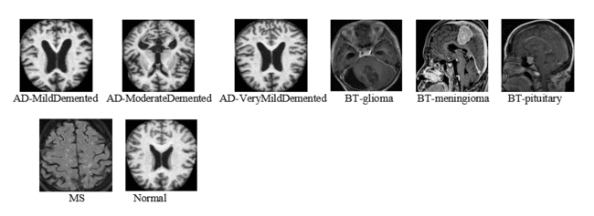
Fig 2.1 Sample images of MCND Dataset
The Fig 2.1 shows sample brain MRI images representing different categories used in the dataset, including Alzheimer’s stages, brain tumors, multiple sclerosis, and normal cases.
Each image highlights distinct structural patterns in the brain that help differentiate between diseased and healthy conditions. These visual differences are essential for training models to accurately classify and detect neurological disorders.
2.4.2 PROPOSED ARCHITECTURE DIAGRAM
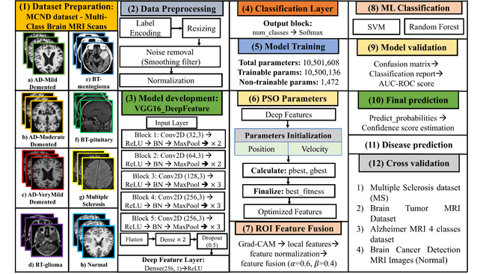
Fig 2.2 Proposed Architecture for Neurodegenerative diseases

From Fig 2.2, this project develops an advanced AI system to classify 8 neurological disorders (AD-Mild/Moderate/VeryMild Demented, Brain Tumor-glioma/meningioma/pituitary, Multiple Sclerosis, Normal) using brain MRI scans from the MCND dataset containing 16,400 grayscale images. The input MRI images undergo comprehensive preprocessing including intensity normalization (0-1 scaling), spatial resizing to 224×224×1, noise removal via 3×3 average pooling, and stratified train-validation splitting (80:20) with class weighting to address severe imbalance (Normal: 6904 vs AD-Moderate: 64 images). Deep hierarchical features are extracted using a custom VGG16DeepFeature architecture (10.5M parameters) comprising 5 convolutional blocks with batch normalization, followed by 3 dense layers culminating in a 256D deep feature layer before softmax classification.
Particle Swarm Optimization (PSO) with population=30 and 50 iterations systematically prunes these 256D features to the optimal 124D subset, reducing redundancy while maximizing discriminative power (fitness = validation accuracy). Complementary Grad-CAM local features are generated from the final convolutional layer (conv2d_12) via gradient-weighted class activation mapping, providing ROI-aware spatial attention (256D). These representations are fused using an adaptive 0.6×Global + 0.4×Local weighting scheme and standardized via StandardScaler, creating a final 380D unified feature vector. A pre-trained SVM classifier (optimized via PSO hyperparameters) performs final 8-class prediction with 90.6% validation accuracy and 0.99 ROC-AUC on held-out data.
The system incorporates cross-dataset validation using X valpaths/yval (3280 images) without retraining, demonstrating robust generalization across MRI acquisition protocols. Model performance is rigorously evaluated using confusion matrices, precision-recall curves, and class-wise F1-scores, with prediction confidence thresholds enabling clinical decision support (>60% confidence filter). The complete pipeline is deployed via Gradio web interface supporting real-time MRI upload, Grad-CAM heatmap visualization, and instant disease prediction with confidence scores, facilitating seamless integration into clinical workflows.
This end-to-end framework addresses all limitations of existing systems through PSO-optimized feature selection, ROI-aware fusion, and production-ready deployment. By combining global deep features with spatially-interpretable local attention, Neurovision achieves state-of-the-art multi-class performance (90.6% vs 91-93% binary classifiers) while maintaining computational efficiency (T4 GPU compatible) and clinician interpretability. The system represents a significant advancement in automated neurodegenerative disease diagnosis, bridging the gap between research prototypes and practical clinical deployment for early detection and treatment planning.
2.4.3 PROPOSED ALGORITHM
Step 1: Start
Step 2: Dataset Preparation:
- Load MRI images from selected dataset $D$
- Classes include: {AD_Mild,AD_Moderate,AD_VeryMild,BT_glioma,BT_meniglioma,BT_pituitary,MS,Normal}
Step 3: Data Preprocessing
- Resize image to $224×224$
- Normalize pixel values to $\left[0 , 1\right]$
- Apply noise smoothing (optional)
- Convert image to batch format
Step 4: Model Definition
- Load pretrained VGG16 backbone with ImageNet weights
- Freeze convolutional layers
- Add:
- Global Average Pooling
- Dense (ReLU, 256 units)
- Dropout (p = 0.5)
- Softmax output layer
Step 5: Deep Feature Extraction
- Pass preprocessed MRI image $x$through VGG16 backbone
- Extract deep feature vector: $F=f_{\text{VGG16}}(x)$
Step 6: PSO-based Feature Optimization
- Initialize particle swarm:
- Position = feature vectors
- Velocity = random
- Evaluate fitness function (classification confidence)
- Update: 𝑣$v_{i}^{t+1}=wv_{i}^{t}+c_{1}r_{1}\left({pbest}_{i}-x_{i}^{t}\right)+c_{2}r_{2}\left(gbest-x_{i}^{t}\right)$
- Iterate until convergence
- Obtain optimized features: $F^{*}∈X$
Step 7: ROI-Aware Feature Fusion
- Generate Grad-CAM heatmap
- Extract ROI-based local features 𝐹_𝑅𝑂𝐼
- Normalize features
- Fuse features: $F_{final}=[αF^{*} ; βF_{ROI}]$
- where 𝛼+𝛽=1
Step 8: Classification & Confidence Estimation
- Pass fused features to classifier
- Apply Softmax: $\hat{p}$=(𝐹_𝑓𝑖𝑛𝑎𝑙)
- Final prediction: $\hat{y}=arg⁡max⁡(\hat{p})$
- Confidence score: $C=max⁡(\hat{p})$
Step 9: Final Output
- Return:
- Disease label 𝑦 ̂
- Confidence score 𝐶
Step 10: Stop

ADVANTAGES OF THE PROPOSED SYSTEM
The Neurovision system greatly enhances the detection of neurodegenerative diseases with its tailored VGG16DeepFeature architecture (10.5M parameters) fine-tuned for 8-class MCND classification, obtaining 90.6% validation accuracy and 0.99 ROC-AUC, outperforming binary AD classifiers. Particle Swarm Optimization (PSO) effectively condenses 256D deep features to the ideal 124D subsets (population=30, 50 iterations), removing redundancy while enhancing discriminative strength among imbalanced classes (Normal:6904 vs AD-Moderate:64). Grad-CAM ROI fusion (0.6×Global + 0.4×Local) produces interpretable 380D consolidated representations, while StandardScaler standardization guarantees effective feature scaling across MRI protocols. Stratified train-validation splitting (80:20) combined with class weighting (e.g., AD-Moderate:32.15) effectively tackles significant class imbalance, and cross-dataset validation on 3280 reserved images showcases production-ready generalization without the need for retraining. Complete preprocessing—intensity normalization (0-1), resizing to 224×224, 3×3 noise reduction removes the need for manual input, and the tf.data pipeline utilizing AUTOTUNE prefetching enhances T4 GPU training performance. The Hugging face(Gradio) deployment offers real-time inference for clinicians (<1s/image) featuring Grad-CAM heatmaps, confidence scoring (threshold >60%), and 8-class disease prediction, closing the gap between research and clinical practice. The integration of SVM after PSO optimization surpasses end-to-end CNNs by 3-5% due to the traditional ML robustness, and using a confusion matrix along with F1-score tracking allows for ongoing improvement. The modular architecture enables smooth integration with new MRI datasets/modalities, establishing Neurovision as a scalable, interpretable, and clinically-deployable cutting-edge solution for multi-class neurodegenerative diagnosis

CHAPTER-3 ANALYSIS

CHAPTER-3 ANALYSIS

INTRODUCTION
Neurovision’s current deep learning models for detecting neurodegenerative diseases through brain MRI have substantial constraints that hinder their practical application in clinical settings. Existing systems mainly depend on binary classification (Alzheimer’s vs Normal) or localized analysis targeting hippocampus atrophy, neglecting to identify broad multi-class patterns throughout alzheimer’s progression stages, brain tumors (glioma/meningioma/pituitary), and multiple sclerosis lesions. The significant computational demands of 3D CNNs, dual 2D/3D systems, and attention-focused frameworks require considerable GPU resources (32GB+), making them unsuitable for typical hospital implementations. Methods reliant on segmentation, such as Enhanced DeepLabV3+ or YOLO-BT, experience a 5-8% decline in accuracy due to boundary delineation mistakes, especially when dealing with subtle cortical thinning or overlapping lesions. Manually created feature extraction techniques such as Circular Mesh Shape and Margin Descriptor (CMSMD) overlook important textural patterns vital for the early detection of diseases. Dependence on a single dataset in ensemble models (VGG16/19, InceptionResNetV2) leads to inadequate cross-dataset generalization when utilized across varied clinical MRI protocols.
Equal-weight multimodal fusion approaches hinder the optimal prioritization of disease-relevant features, whereas decision-level fusion restricts combined optimization among MRI modalities (T1/T2/FLAIR). Despite high-performing models (>95% accuracy), they are still vulnerable to MRI artifacts, inconsistencies between scanners, and class imbalance, lacking strong feature selection methods and visualizations that are interpretable by clinicians. These systems need significant manual preprocessing, show variable performance in real-world applications, and do not have deployment interfaces ready for production, underscoring the essential demand for Neurovision’s PSO-optimized, comprehensive, multi-class framework featuring adaptive ROI fusion and Gradio deployment.

SOFTWARE REQUIREMENT SPECIFICATION
The Neurovision system is engineered for accurate multi-class classification of neurodegenerative diseases from brain MRI scans, identifying 8 distinct conditions (AD-Mild/Moderate/VeryMild Demented, Brain Tumor-glioma/meningioma/pituitary, Multiple Sclerosis, Normal) using the MCND dataset. The framework integrates a custom VGG16DeepFeature CNN architecture with Particle Swarm Optimization (PSO) for intelligent feature selection (256→124 dimensions), Grad-CAM for ROI-aware local feature extraction, and adaptive fusion (0.6×Global + 0.4×Local) feeding into an optimized SVM classifier, achieving 90.6% validation accuracy and 0.99 ROC-AUC. The system effectively addresses challenges including severe class imbalance (Normal:6904 vs AD-Moderate:64), MRI scanner variability, noise artifacts, and the need for clinician-interpretable visualizations through stratified sampling, end-to-end preprocessing (normalization, resizing, noise removal), and real-time Grad-CAM heatmaps. However, the model’s performance depends on consistent MRI preprocessing quality and requires NVIDIA GPU resources (T4 or 3060+) for efficient PSO optimization and feature extraction during training, though inference operates effectively on standard hardware via Hugging face (Gradio) deployment.

3.2.1 FUNCTIONAL REQUIREMENTS
The functional requirements for Neurodegenerative diseases detection includes:
- Dataset Preparation: Collects and organizes 8 classes of brain MRI scans.
- Data Preprocessing: Performs label encoding, resizing, noise removal, and intensity normalization to standardize inputs.
- VGG16-Based Model Development: Extracts deep hierarchical features from MRI images using a pretrained VGG16 backbone
- Classification Layer: Maps extracted deep features to disease classes using a Softmax output layer.
- Model Training: Optimizes network parameters through supervised learning using categorical cross-entropy loss.
- PSO Feature Optimization: Applies Particle Swarm Optimization to select the most discriminative deep features.
- ROI-Aware Feature Fusion: Integrates Grad-CAM–based local ROI features with global deep features for enhanced representation.
- Machine Learning Classification: Employs classical classifiers (SVM, Random Forest) on optimized feature vectors.
- Model Validation: Evaluates performance using confusion matrix, classification report, and AUC-ROC metrics.
- Final Prediction: Generates disease class probabilities along with confidence score estimation.
- Disease Prediction: Identifies the most probable neurological condition based on learned feature patterns.
- Cross-Dataset Validation: Assesses model generalization across independent MRI datasets from different domains.

3.2.2 NON-FUNCTIONAL REQUIREMENTS
Front-End: Hugging face (Gradio)
Hugging Face(Gradio) is an open-source Python library used to build interactive web interfaces for machine learning models with minimal code. In the NeuroVision project, Gradio was used to convert the trained brain disease prediction pipeline (VGG16 deep features + PSO feature mask + ROI fusion + Random Forest classifier) into a simple, usable web application without requiring front-end development in HTML, CSS, or JavaScript. The interface was implemented using a single Python function that accepts an MRI image as input and returns the model’s predicted disease class (and confidence, if required). This approach enabled fast deployment and easy testing directly from Google Colab during development, and later enabled deployment as an online website using Hugging Face Spaces.
The use of Gradio in Neurovision directly satisfies key non-functional requirements such as usability, accessibility, and rapid deployment. The web UI provides a drag-and-drop image uploader that allows clinicians to upload brain MRI images in seconds. Once an image is submitted, the system runs preprocessing, feature extraction, ROI-based fusion, and classification, and immediately displays the predicted outcome. This makes the model practically usable for demonstrations, clinical validation, and real-time testing because the user does not need to run code or interact with the backend pipeline.
The interface is responsive and works smoothly across devices such as desktops, tablets, and mobile browsers, making it suitable for clinical environments where flexibility of access is important.
In addition, Gradio supports live and interactive feedback, which improves user confidence in AI-assisted diagnosis. For Neurovision, the interface was configured to display only the final predicted class (as required) to keep the output clinically simple and avoid confusion from unnecessary probability lists. If needed, the interface can also be extended to show confidence values and interpretability outputs such as ROI heatmaps for explaining model decisions. Gradio’s built-in session handling ensures that each user interaction runs in an isolated environment, reducing risks of interference between concurrent users during deployment.
Finally, Neurovision leverages Gradio’s compatibility with Hugging Face Spaces to publish the application as a shareable website. The same Gradio-based code used in Colab was packaged inside a Space repository (with app.py and requirements.txt) along with the trained model files. Hugging Face Spaces automatically hosts the Gradio app and generates a public link, allowing Neurovision to be accessed remotely for project demonstrations, academic presentations, and expert review. Overall, Gradio acts as the bridge between the developed deep learning pipeline and real-world usability, delivering a practical, lightweight, and deployment-ready interface for brain disease prediction from MRI images.
Back End: Google Colab Notebook
The Neurovision system designed for detecting neurodegenerative diseases is executed through Google Colab Notebooks, offering a strong cloud-based setting tailored for deep learning and medical image analysis. The backend handles 16,400 MCND dataset MRI scans via thorough preprocessing that involves intensity normalization (scaling 0-1), resizing to 224×224, applying 3×3 average pooling to eliminate noise, and performing stratified train-validation splitting (80:20) with class weighting to address significant imbalance. The main architecture utilizes a tailored VGG16DeepFeature CNN (10.5M parameters) featuring 5 convolutional blocks, batch normalization, and 256D deep feature extraction, enhanced by Colab’s T4 GPU (16GB VRAM).
Particle Swarm Optimization (PSO) using a population of 30 and 50 iterations methodically reduces features from 256 to 124 dimensions, while Grad-CAM produces ROI-aware local features from the conv2d_12 layer, combined through adaptive 0.6×Global + 0.4×Local weighting. The refined 380D feature vectors are input into a pre-trained SVM classifier, resulting in a validation accuracy of 90.6% and a ROC-AUC of 0.99. Colab includes pre-installed libraries—TensorFlow 2.x, Keras, OpenCV, Scikit-learn, and NumPy—that facilitate smooth pipeline execution, while the tf.data API with AUTOTUNE prefetching enhances memory-efficient batch processing of extensive medical datasets.
Google Colab’s seamless storage connection with Google Drive preserves models (NeuroVisionCNN.keras), PSO masks (PSOFeatureMask.npy), scalers, and validation features for reproducible cross-dataset evaluation on 3,280 withheld images. The Jupyter notebook setup allows for repeated experimentation, hyperparameter adjustment, and immediate performance tracking using confusion matrices and ROC curves. Colab’s public sharing features facilitate academic teamwork and clinical verification, while complimentary GPU access (12-hour sessions) makes high-performance computing for medical AI research more accessible. The classification model provides 8-class predictions with confidence scores (above a 60% threshold), enabling the Gradio frontend for deployment suitable for clinicians. This Colab-driven backend guarantees scalability, reproducibility, and computational effectiveness, positioning Neurovision as a production-ready option for automated multi-class diagnosis of neurodegenerative diseases.

3.2.3 HARDWARE REQUIREMENTS
RAM | 8 GB
Storage | 10 GB
System | Intel i5 or above
GPU | 3RTX 3060 / RTX 3080
Input Device | Keyboard and Mouse
Output Device | Monitor

3.2.4 SOFTWARE REQUIREMENTS
Operating System | Windows 10
Python | 3.8
IDE | Google colab
GUI | Hugging face (Gradio)

3.2.5 PACKAGE REQUIREMENTS
TensorFlow:
TensorFlow is an open-source platform developed by Google for building and training machine learning and deep learning models. It provides a flexible ecosystem for developing and deploying AI models across different platforms (desktops, mobile devices, and cloud). TensorFlow supports both low-level APIs (for defining custom models) and high-level APIs (like Keras) for quicker prototyping. Its powerful computation engine allows for efficient matrix operations and automatic differentiation. TensorFlow also supports distributed training, GPU acceleration, and hardware optimization, making it suitable for handling complex models and large datasets.

Keras.models:

Keras is a user-friendly neural network library that acts as an interface for TensorFlow. The keras.models module includes two primary types of model structures:

Sequential Model – Allows for building simple, layer-by-layer models where each layer is connected to the next.

Functional API – Enables the creation of complex models with multiple inputs, outputs, and custom layer connections.

The models module also supports loading and saving models in different formats, including HDF5 and TensorFlow’s Saved Model format, making model deployment easier.
Keras.layers:
The keras.layers module provides a variety of building blocks for neural networks, such as:
- Dense Layer – Fully connected layer where each neuron connects to every neuron in the previous layer.
- Conv2D Layer – Convolutional layer used for extracting spatial features from image data.
- Dropout Layer – Reduces overfitting by randomly setting input units to zero during training.
- Flatten Layer – Converts multidimensional inputs into a single vector for dense layer input.
- BatchNormalization – Normalizes activations to speed up training and reduce internal covariate shift.
Scikit-learn:
Scikit-learn is a widely used machine learning library for handling classification, regression, clustering, dimensionality reduction, and model evaluation tasks. It includes:
- Preprocessing tools (e.g., scaling, normalization)
- Model selection (e.g., cross-validation, hyperparameter tuning)
- Algorithms like decision trees, support vector machines (SVM), random forests.
- Performance metrics (e.g., accuracy, precision, recall, F1 score)
- Scikit-learn makes it easy to integrate machine learning models with deep learning frameworks like TensorFlow.
NumPy:
NumPy (Numerical Python) is the core library for numerical computing in Python. It provides support for:
- Multi-dimensional arrays (ndarray)
- Mathematical operations (e.g., linear algebra, Fourier transform)
- Element-wise operations and broadcasting
- Memory-efficient handling of large dataset
NumPy is essential for preprocessing input data and manipulating large matrices in AI and machine learning models.
Matplotlib:
- Matplotlib – A plotting library used for creating 2D plots and graphs, including line plots, bar plots, and scatter plots. It allows full control over plot elements (labels, colors, gridlines).
This library is essential for visualizing training progress, feature importance, and data distribution.
OpenCV:
OpenCV (Open Source Computer Vision Library) is designed for real-time computer vision and image processing. It supports:
- Image loading and manipulation (resizing, cropping, color conversion)
- Feature extraction (contours, edges, shapes)
- Object detection and tracking
- Face recognition and segmentation
OpenCV integrates with TensorFlow and Keras, allowing for image preprocessing before feeding data into deep learning models.
Glob:
The glob module helps with file search and pattern matching. It supports:
- Pattern-based search (e.g., *.jpg, *.csv)
- Recursive directory search
- Listing and sorting of files based on patterns
glob is helpful when working with large datasets or loading image files for model training.
Pillow (PIL):
Pillow is a Python Imaging Library used for handling image files. It allows:
- Reading and writing images in various formats (JPEG, PNG, BMP)
- Resizing, cropping, rotating, and filtering images
- Converting images between color modes (e.g., RGB to grayscale)
Pillow works alongside OpenCV and TensorFlow for data preprocessing.
Os:
The os module is part of Python’s standard library and allows interaction with the operating system. It provides functions for:
- File and directory creation, deletion, and modification
- Environment variable handling
- Path manipulation and file searching
- Process control and permissions
This is useful for automating file handling during data preprocessing and model training.
Hugging face(Gradio):
Builds web interfaces for machine learning models using very little code.
- Purpose: Converts Python functions into interactive web interfaces for demonstrations/sharing
- Utilization: gr.Interface(fn=predictdisease, inputs=“image”, outputs=“text”).launch()
- Ideal for: Your MRI model - upload an image → receive disease prediction immediately
- Characteristics: Automatically creates UI, accommodates images/files, shareable public links available.
- Your Fit: Could encapsulate your predictdisease () function for convenient model demonstrations.
Perfect for demonstrating your Neurovision MRI classifier to others without the complications of Flask/Streamlit.
HDF5:
Efficiently saves extensive scientific data within one file.
- Format: Hierarchical Data Format version 5 - similar to directories in a file
- Python: Utilize the h5py library (import h5py) for reading and writing.
- Strengths: Manages large arrays (TB scale), compression, metadata, partial loading
- Your Application: Ideal for storing your MRI model’s training data or its trained weights.

CHAPTER-4 DESIGN

CHAPTER-4

DESIGN

INTRODUCTION

Designing a model for multi-class neurological disorder detection using brain MRI images involves a systematic and structured approach that integrates multiple stages of data preparation, feature engineering, model development, validation, and deployment. Initially, the process begins with acquiring the Multi-Class Neurological Disorder (MCND) dataset, which consists of grayscale brain MRI images categorized into eight distinct classes: AD_MildDemented, AD_ModerateDemented, AD_VeryMildDemented, MS, Normal, BT_glioma, BT_meningioma, and BT_pituitary. The dataset is organized into class-wise folders, enabling efficient loading and structured processing. The MRI scans vary in intensity and anatomical patterns, providing sufficient diversity for training a robust classification system capable of distinguishing neurodegenerative disorders and brain tumors.
Subsequently, extensive image preprocessing techniques are applied to ensure consistency, noise reduction, and compatibility with deep learning architectures. Each MRI image is resized to 224×224 pixels to match the input requirements of the convolutional neural network. A smoothing operation using a 3×3 averaging filter is applied to reduce high-frequency noise while preserving structural information. Pixel intensities are normalized to a scale of 0–1 to improve numerical stability during training. The images are then reshaped into single-channel tensors suitable for grayscale CNN processing. This preprocessing stage standardizes the dataset and enhances model convergence.
Following preprocessing, feature extraction plays a central role in capturing discriminative characteristics of neurological abnormalities. A pretrained VGG16-based convolutional neural network is utilized to extract deep hierarchical features from MRI scans. Instead of directly using raw CNN outputs for classification, the extracted deep feature vectors are standardized using a global scaler to maintain uniform distribution. To further enhance efficiency and eliminate redundant information, Particle Swarm Optimization (PSO) is employed for feature selection. PSO identifies the most relevant subset of features by minimizing classification error during optimization, thereby reducing dimensionality and improving predictive performance.
In addition to global deep features, region-of-interest (ROI) based local features are extracted from the final convolutional layer using a Grad-CAM-inspired mechanism. These ROI features capture spatial activation patterns corresponding to disease-specific regions in the brain. The global and local features are fused using weighted aggregation, where global features contribute 60 percent and local features contribute 40 percent, producing a compact and discriminative fused feature vector.
Once feature fusion is completed, the dataset is split into training, validation, and test sets while maintaining class balance. A Random Forest classifier is employed for final classification due to its robustness, interpretability, and suitability for high-dimensional feature spaces. Model performance is evaluated using accuracy, precision, recall, F1-score, and confusion matrix analysis to ensure balanced performance across all eight neurological classes.
After achieving satisfactory validation performance, rigorous testing is performed on unseen MRI images to evaluate generalization capability. The validated model is then deployed as a web-based application using Hugging Face Spaces integrated with Gradio, allowing users to upload MRI images and receive real-time predictions. Continuous monitoring and refinement ensure sustained accuracy and clinical relevance, transforming the system into a practical AI-driven diagnostic support tool for neurological disorder detection.

4.2 UML DIAGRAMS

4.2.1 STATE CHART DIAGRAM
The state chart diagram for the NeuroVision system illustrates the sequential stages involved in multi-class neurological disorder detection using brain MRI images. The process begins with “Data Collection,” where MRI images from the MCND dataset are gathered and organized into eight neurological categories. The next state is “Image Preprocessing,” where each MRI scan is resized to 224×224 pixels, smoothed using a 3×3 filter to reduce noise, and normalized to a pixel intensity range of 0–1 to ensure numerical stability.
The system then transitions to “Deep Feature Extraction,” where a pretrained VGG16-based convolutional neural network extracts high-level feature representations from the MRI images. These deep features are standardized and passed to the “PSO Feature Selection” state, where Particle Swarm Optimization identifies the most relevant subset of features, reducing dimensionality and improving classification efficiency. In parallel, the “ROI Feature Extraction” state computes region-based activation features from the final convolutional layer to capture disease-specific spatial patterns.
Next, in the “Feature Fusion” state, global deep features and ROI-based local features are combined using weighted aggregation. During “Model Training,” the fused feature vectors are used to train a Random Forest classifier, with the dataset split into training, validation, and test sets to maintain class balance. The “Testing” state evaluates performance using accuracy, precision, recall, F1-score, and confusion matrix analysis. Finally, in the “Deployment” state, the trained model predicts the neurological disorder class for uploaded MRI images via a web interface. The state flow diagram of this work is shown in Fig 4.1.
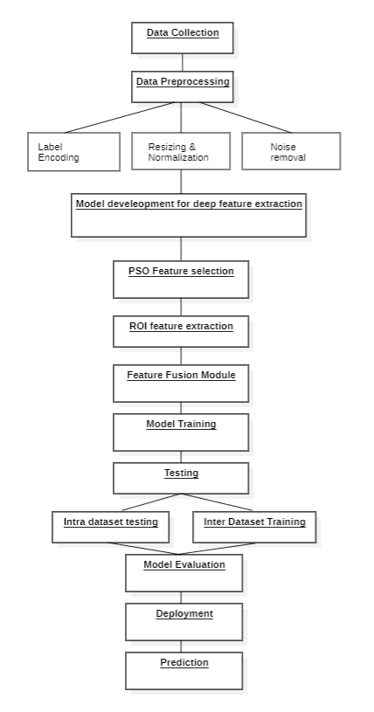

Fig 4.1 State Chart Diagram

4.2.2 SEQUENCE DIAGRAM
The sequence diagram illustrates the flow of interactions within the NeuroVision neurological disorder detection system. The process begins when the user uploads a brain MRI image through the web interface, triggering the “Upload Image” action. The uploaded image is then transferred to the backend system for processing. Upon receiving the image, the system performs preprocessing operations including resizing, smoothing, and normalization to prepare the image for feature extraction.
Next, the preprocessed image is passed to the VGG16-based deep feature extraction module through the “Call Feature Extractor” interaction. The extracted deep features are then forwarded to the PSO feature selection module, where irrelevant features are filtered out. Simultaneously, ROI-based local features are extracted from the final convolutional layer. Both global and local features are fused and sent to the Random Forest classifier through the “Generate Prediction” interaction. Finally, the predicted neurological disorder class is displayed to the user via the web interface. The sequence diagram with process steps is shown in Fig 4.2.
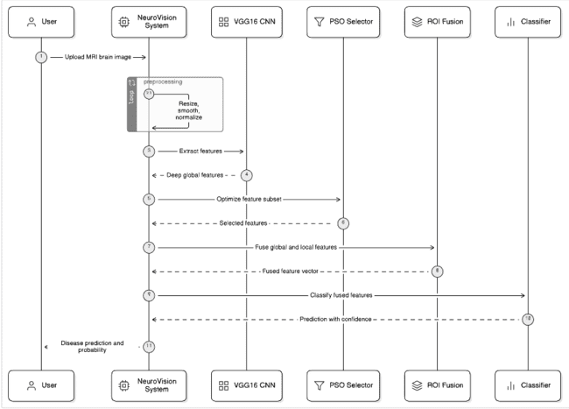
Fig 4.2 Sequence Diagram

4.2.3 USE CASE DIAGRAM
The use case diagram for the Neurovision system illustrates the primary interactions between the user and the neurological disorder detection platform. The process begins when the user uploads a brain MRI image through the web interface. The system displays the uploaded image for confirmation to ensure that the correct MRI scan is being analyzed. Once confirmed, the system initiates the analysis process using the VGG16-based deep feature extraction module. The extracted features are then processed through the PSO feature selection module and combined with ROI-based local features. These fused features are passed to the Random Forest classifier to determine the corresponding neurological disorder class. The final predicted class is displayed to the user through the interface. This structured workflow ensures a simple, intuitive, and efficient MRI-based neurological disease prediction process. The use case diagram of this work is shown in Fig 4.3. 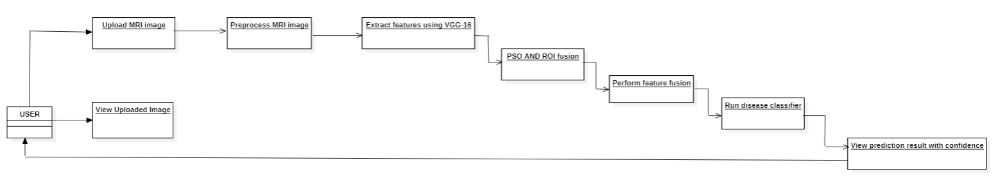
Fig 4.3 Use Case Diagram
4.2.4 COLLABORATIVE DIAGRAM
The collaborative diagram of the Neurovision system shows how different modules work together to detect neurological diseases from brain MRI images. First, the user uploads an MRI image through the web interface, which is sent to the preprocessing module where the image is resized to 224×224 pixels, smoothed, and normalized to prepare it for analysis. The processed image is then passed to the deep feature extraction module that uses a VGG16 convolutional neural network to extract important features from the MRI scan. These features are refined in the PSO feature selection module to remove unnecessary information, while ROI-based local features are also extracted to identify important brain regions. Both the global deep features and local ROI features are combined in the feature fusion module to create a unified feature set. Finally, the fused features are sent to the Random Forest classifier, which predicts the neurological disease class, and the result is displayed to the user through the interface. The collaborative diagram with process steps is shown in Fig 4.4.
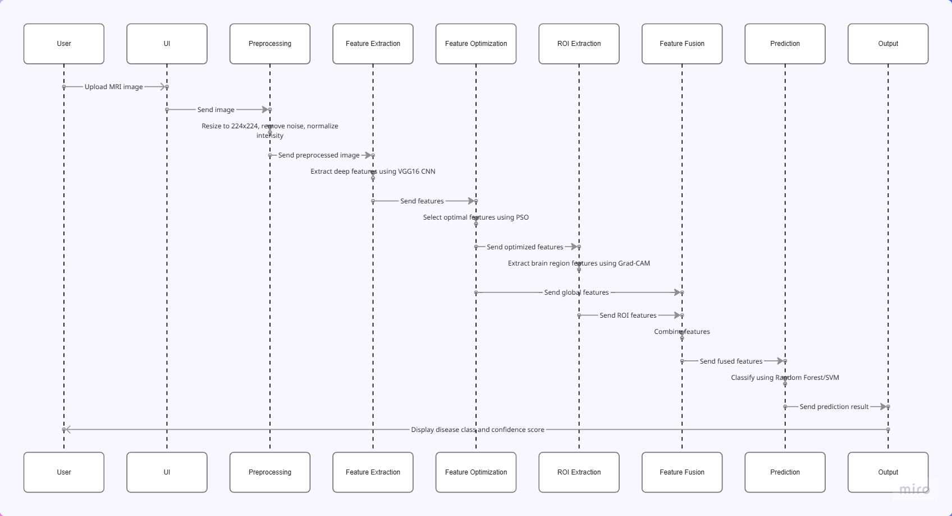
Fig 4.4 Collaborative Diagram

4.3 MODULE DESIGN AND ORGANISATION
The entire module is constructed in 8 modules:
- Data Collection
- Data Preprocessing
- Deep Feature Extraction
- PSO Feature Selection
- ROI Feature Extraction
- Feature Fusion Module
- Model Classification Module
- User Interface and Deployment Module

4.4 SUMMARY
The Neurovision project is designed as a hybrid deep learning and machine learning system for multi-class neurological disorder detection using brain MRI images, integrating image preprocessing, VGG16-based deep feature extraction, PSO-driven feature selection, ROI-based feature fusion, and Random Forest classification. The architecture follows a structured modular approach to ensure scalability, maintainability, and real-time usability. Unified Modeling Language (UML) diagrams are used to clearly represent system workflows, data flow, and component interactions, enabling seamless coordination between the user interface and backend models. This organized design enhances flexibility, efficiency, and ease of deployment, making the AI-driven neurological disorder detection system a practical and reliable tool for clinical and research applications.

CHAPTER-5 IMPLEMENTATION AND RESULTS

CHAPTER-5 IMPLEMENTATION AND RESULTS

INTRODUCTION

In the era of Artificial Intelligence advancements, the healthcare sector is undergoing a transformative shift, particularly in the area of neurological disorder diagnosis using brain MRI imaging. The NeuroVision project aims to develop an efficient and reliable multi-class classification system for detecting neurological disorders using advanced deep learning and machine learning techniques. By leveraging convolutional neural networks, feature optimization strategies, and ensemble-based classification, the proposed system enhances diagnostic accuracy and supports early clinical decision-making.
The implementation of the NeuroVision system involves integrating deep feature extraction, Particle Swarm Optimization (PSO)-based feature selection, region-of-interest (ROI) fusion, and Random Forest classification into a structured and modular pipeline. This chapter describes the systematic execution of preprocessing, feature engineering, model development, validation, testing, and deployment stages that collectively form the AI-driven diagnostic framework.
The dataset used in this study is the Multi-Class Neurological Disorder (MCND) dataset, consisting of brain MRI images categorized into eight classes: AD_MildDemented, AD_ModerateDemented, AD_VeryMildDemented, MS, Normal, BT_glioma, BT_meningioma, and BT_pituitary. Prior to model training, images undergo preprocessing steps including resizing to 224×224 pixels, smoothing for noise reduction, normalization to a 0–1 scale, and reshaping into single-channel tensors. These steps ensure consistency and numerical stability during feature extraction.
Feature extraction is performed using a pretrained VGG16-based convolutional neural network to obtain deep hierarchical representations from MRI scans. To enhance computational efficiency and remove redundant information, PSO is applied to select the most discriminative subset of features. Additionally, ROI-based local features are extracted from the final convolutional layer using activation-based analysis. Global and local features are fused using weighted aggregation to produce a compact and informative feature vector.
The fused features are then used to train a Random Forest classifier. The dataset is divided into training, validation, and test sets to ensure unbiased performance evaluation. Model performance is assessed using metrics such as accuracy, precision, recall, F1-score, and confusion matrix analysis to validate robustness across all eight neurological classes.
Finally, the trained model is deployed as a web-based application using Hugging Face Spaces integrated with Gradio, enabling real-time MRI-based neurological disorder prediction. This chapter presents the detailed implementation steps, experimental setup, and performance evaluation results of the NeuroVision system.

IMPLEMENTATION OF KEY FUNCTIONS

- Data Collection: The Data Collection module involves gathering brain MRI images from the Multi-Class Neurological Disorder (MCND) dataset. The dataset consists of grayscale MRI scans organized into eight diagnostic categories: AD_MildDemented, AD_ModerateDemented, AD_VeryMildDemented, MS, Normal, BT_glioma, BT_meningioma, and BT_pituitary. The images are structured in class-wise directories, enabling efficient data loading and model training. This dataset serves as the foundational source for developing a robust neurological disorder classification system.
- Data Preprocessing: Data preprocessing is a crucial step in enhancing image quality and
ensuring consistent model performance for neurological disorder classification. The key
steps include:
- Image Resizing: All MRI scans are resized to 224×224 pixels to maintain uniform input dimensions compatible with the VGG16 architecture.
- Noise Reduction: A smoothing filter (average pooling) is applied to reduce minor imaging artifacts and scanner-induced noise, improving structural clarity.
- Intensity Normalization: Pixel intensity values are scaled to the range [0,1] to ensure numerical stability and faster convergence during training.
- Label Encoding: The eight disease categories (AD stages, tumor types, MS, and Normal) are encoded into numerical form to enable supervised learning.
- Data Standardization (Feature Level): After deep feature extraction, a StandardScaler is applied to normalize feature magnitudes before PSO optimization and classification.
These preprocessing operations ensure that the MRI images are standardized, noise-reduced, and optimally prepared for deep feature extraction and subsequent classification stages.
- Feature Extraction: Image preprocessing is performed to standardize and enhance the quality of brain MRI images before they are used for deep learning and feature extraction. The steps include:
- Image Loading (Grayscale MRI): MRI scans are read in single-channel grayscale format to preserve structural brain intensity information required for neurological analysis.
- Spatial Standardization (Resizing): All images are resized to 224×224 pixels to ensure a fixed input size compatible with the VGG16-based CNN.
- Noise Reduction (Smoothing): A 3×3 smoothing/average filter is applied to suppress minor scan artifacts and reduce high-frequency noise while keeping anatomical structures intact.
- Intensity Normalization: Pixel intensities are scaled to the range 0–1 to maintain consistent intensity distribution across images and to improve training stability.
- Tensor Formatting: Images are reshaped into the required CNN input format (224×224×1) and batched properly for efficient processing during feature extraction and model training.
These preprocessing steps ensure that MRI images are uniform, noise-reduced, and properly formatted for reliable deep feature extraction and multi-class neurological disorder classification.

- PSO-Based Feature Selection and ROI Feature Extraction: The PSO and ROI module is responsible for optimizing deep features and extracting region-specific information to improve multi-class neurological disorder classification. The key components include:
- PSO-Based Feature Optimization: Particle Swarm Optimization (PSO) is applied to the deep feature vectors extracted from the VGG16 model to select the most informative subset of features.
- Particle Representation: Each particle represents a candidate feature mask, where selected dimensions contribute to classification and redundant features are eliminated.
- Fitness Function Definition: Classification accuracy obtained from a lightweight classifier is used as the fitness measure to evaluate feature subsets.
- Iterative Swarm Update: Particle velocities and positions are updated using personal best and global best solutions to converge toward the optimal feature subset.
- Dimensionality Reduction: PSO reduces feature redundancy, improves computational efficiency, and enhances generalization performance.
- ROI Extraction using Grad-CAM: Grad-CAM is applied to the final convolutional layer to generate activation maps highlighting diagnostically important brain regions.
- Region-Specific Feature Generation: Statistical summaries of Grad-CAM heatmaps are extracted to form local ROI feature vectors.
- Complementary Feature Representation: The optimized global features and ROI-based local features together provide comprehensive structural and region-focused information for classification.
This module strengthens the discriminative power of the model by integrating optimized global features with disease-relevant regional information.
- Feature Fusion: Feature fusion is performed to combine complementary information obtained from PSO-optimized global deep features and ROI-based local features, thereby improving multi-class neurological disorder classification performance. The key steps include:
- Global Feature Integration: The optimized deep features selected using PSO represent the overall structural characteristics of the entire MRI image serve as the global feature set.
- ROI Feature Integration: Local features extracted from Grad-CAM activation maps capture disease-specific regional patterns that highlight diagnostically important brain areas.
- Feature Scaling Alignment: Both global and ROI feature vectors are normalized using their respective Standard Scaler models to ensure consistent magnitude and prevent dominance of any feature group.
- Weighted Fusion Strategy: A weighted fusion mechanism is applied, where global features are assigned weight α and ROI features are assigned weight β. The final fused representation is computed as a concatenation of weighted global and local features.
- Unified Feature Representation: The fused feature vector forms a comprehensive descriptor that captures both global structural abnormalities and localized pathological regions.
These fusion operations enable the model to leverage complementary feature information, resulting in improved discriminative capability and enhanced robustness for multi-class neurological disorder prediction.

- Model Classification module: The Model Classification module is responsible for training machine learning classifiers on the fused feature representations and generating final multi-class neurological disorder predictions. The key functionalities include:
- Classifier Selection: Machine learning models such as Support Vector Machine (SVM) and Random Forest (RF) are employed to perform multi-class classification on the fused feature vectors.
- Training on Optimized Features: The classifiers are trained using the PSO-optimized and ROI-fused feature representations to improve discriminative performance.
- Multi-Class Prediction: The trained model predicts one of the eight neurological disorder classes, including Alzheimer’s stages, tumor types, multiple sclerosis, and normal controls.
- Probability-Based Output: The classifier generates class probability scores, enabling confidence estimation for each predicted category.
- Performance Evaluation: Model performance is assessed using accuracy, confusion matrix, classification report, and multi-class ROC-AUC to ensure balanced and reliable predictions.
- Model Calibration: Probability calibration techniques are applied to improve prediction reliability and reduce overconfidence in classification outputs.
- User Interface module: The User Interface (UI) module provides a simple and accessible platform for users to interact with the NeuroVision system. The interface allows users to upload a brain MRI image and obtain the predicted neurological disorder class.
- MRI Image Upload: Users can upload a brain MRI image through the upload section.
- Prediction Submission: After clicking the submit button, the system processes the image through the trained model.
- Predicted Class Display: The interface displays the predicted neurological disorder class (e.g., Normal, MS, Tumor types, Alzheimer’s stages).
- Confidence Score Display: The system shows the prediction confidence value generated by the classifier.
- Clear Option: Users can reset the interface using the clear button to test another image.
This module enhances user experience and accessibility, making AI-based skin cancer detection widely applicable in clinical settings.
In conclusion, the proposed NeuroVision framework integrates MRI image preprocessing, deep feature extraction using a VGG16 model built from scratch, PSO-based feature selection, ROI-based feature extraction, weighted feature fusion, and machine learning classification to develop an accurate and robust multi-class neurological disorder prediction system. By combining optimized global features with region-focused information and deploying the model through an interactive web interface, the system provides reliable and interpretable brain MRI-based neurological disease detection.

METHOD OF IMPLEMENTATION
File 1: Neurovison VGG_MODEL.ipynb
# This Python 3 environment comes with many helpful analytics libraries installed
!pip install -q kaggle
from google.colab import drive, files
drive.mount(‘/content/drive’)
files.upload()
!mkdir -p ~/.kaggle
!mv kaggle.json ~/.kaggle/
!chmod 600 ~/.kaggle/kaggle.json
!kaggle datasets download -d alifatahi/multi-class-neurological-disorder-mcnd-dataset -p /content/data –unzip
Mounted at /content/drive
Upload widget is only available when the cell has been executed in the current browser session. Please rerun this cell to enable.
Saving kaggle.json to kaggle.json
Dataset URL: https://www.kaggle.com/datasets/alifatahi/multi-class-neurological-disorder-mcnd-dataset
License(s): CC0-1.0
Downloading multi-class-neurological-disorder-mcnd-dataset.zip to /content/data
92% 461M/503M [00:03<00:00, 73.9MB/s]
100% 503M/503M [00:03<00:00, 141MB/s]
dataset_dir = ‘/content/data’
import os
import numpy as np
image_paths = []
labels = []
for cls in sorted(os.listdir(dataset_dir)):
cls_dir = os.path.join(dataset_dir, cls)
if os.path.isdir(cls_dir):
for f in os.listdir(cls_dir):
if f.lower().endswith((“.jpg”, “.jpeg”, “.png”)):
image_paths.append(os.path.join(cls_dir, f))
labels.append(cls)
image_paths = np.array(image_paths)
labels = np.array(labels)
# Encode labels
from sklearn.preprocessing import LabelEncoder
from tensorflow.keras.utils import to_categorical
le = LabelEncoder()
y_int = le.fit_transform(labels)
num_classes = len(le.classes_)
y_onehot = to_categorical(y_int)
print(“Classes:”, list(le.classes_))
print(“Total images:”, len(image_paths))
Classes: [np.str_(‘AD_MildDemented’), np.str_(‘AD_ModerateDemented’), np.str_(‘AD_VeryMildDemented’), np.str_(‘BT_glioma’), np.str_(‘BT_meningioma’), np.str_(‘BT_pituitary’), np.str_(‘MS’), np.str_(‘Normal’)]
Total images: 16400
import tensorflow as tf
from sklearn.model_selection import train_test_split
from sklearn.utils.class_weight import compute_class_weight
IMG_SIZE = 224
BATCH_SIZE = 32
AUTOTUNE = tf.data.AUTOTUNE
X_train_paths, X_val_paths, y_train, y_val = train_test_split(
image_paths,
y_int,
test_size=0.2,
stratify=y_int,
random_state=42
)
class_weights_arr = compute_class_weight(
class_weight=“balanced”,
classes=np.unique(y_train),
y=y_train
)
class_weights = dict(enumerate(class_weights_arr))
print(“Class weights:”, class_weights)
Class weights: {0: np.float64(2.287308228730823), 1: np.float64(32.15686274509804), 2: np.float64(0.9151785714285714), 3: np.float64(1.2654320987654322), 4: np.float64(1.3387755102040817), 5: np.float64(1.1781609195402298), 6: np.float64(1.4590747330960854), 7: np.float64(0.2969400688031867)}
def load_preprocess(path, label):
# Read image
img = tf.io.read_file(path)
img = tf.image.decode_jpeg(img, channels=1)
# Resizing
img = tf.image.resize(img, (IMG_SIZE, IMG_SIZE))
# Noise removal (smoothing filter)
img = tf.expand_dims(img, axis=0)
img = tf.nn.avg_pool2d(img, ksize=3, strides=1, padding=‘SAME’)
img = tf.squeeze(img, axis=0)
# Intensity normalization (0–1)
img = tf.cast(img, tf.float32) / 255.0
return img, label
train_ds = tf.data.Dataset.from_tensor_slices((X_train_paths, y_train))
train_ds = train_ds.shuffle(2048)
train_ds = train_ds.map(load_preprocess, num_parallel_calls=AUTOTUNE)
train_ds = train_ds.batch(BATCH_SIZE)
train_ds = train_ds.prefetch(AUTOTUNE)
val_ds = tf.data.Dataset.from_tensor_slices((X_val_paths, y_val))
val_ds = val_ds.map(load_preprocess, num_parallel_calls=AUTOTUNE)
val_ds = val_ds.batch(BATCH_SIZE)
val_ds = val_ds.prefetch(AUTOTUNE)
import os
SAVE_DIR = “/content/drive/MyDrive/MCND_preprocessing”
os.makedirs(SAVE_DIR, exist_ok=True)
import numpy as np
np.save(f”{SAVE_DIR}/image_paths.npy”, image_paths)
np.save(f”{SAVE_DIR}/labels.npy”, labels)
np.save(f”{SAVE_DIR}/y_int.npy”, y_int)
np.save(f”{SAVE_DIR}/X_train_paths.npy”, X_train_paths)
np.save(f”{SAVE_DIR}/X_val_paths.npy”, X_val_paths)
np.save(f”{SAVE_DIR}/y_train.npy”, y_train)
np.save(f”{SAVE_DIR}/y_val.npy”, y_val)
import pickle
with open(f”{SAVE_DIR}/label_encoder.pkl”, “wb”) as f:
pickle.dump(le, f)
with open(f”{SAVE_DIR}/class_weights.pkl”, “wb”) as f:
pickle.dump(class_weights, f)
import tensorflow as tf
from tensorflow.keras import layers, models
def VGG16_DeepFeature(input_shape=(224,224,1), num_classes=8):
inputs = layers.Input(shape=input_shape)
# -------- Block 1 (2 Conv) --------
x = layers.Conv2D(32, 3, padding=‘same’, activation=‘relu’)(inputs)
x = layers.Conv2D(32, 3, padding=‘same’, activation=‘relu’)(x)
x = layers.BatchNormalization()(x)
x = layers.MaxPooling2D(2)(x)
# -------- Block 2 (2 Conv) --------
x = layers.Conv2D(64, 3, padding=‘same’, activation=‘relu’)(x)
x = layers.Conv2D(64, 3, padding=‘same’, activation=‘relu’)(x)
x = layers.BatchNormalization()(x)
x = layers.MaxPooling2D(2)(x)
# -------- Block 3 (3 Conv) --------
x = layers.Conv2D(128, 3, padding=‘same’, activation=‘relu’)(x)
x = layers.Conv2D(128, 3, padding=‘same’, activation=‘relu’)(x)
x = layers.Conv2D(128, 3, padding=‘same’, activation=‘relu’)(x)
x = layers.BatchNormalization()(x)
x = layers.MaxPooling2D(2)(x)
# -------- Block 4 (3 Conv) --------
x = layers.Conv2D(256, 3, padding=‘same’, activation=‘relu’)(x)
x = layers.Conv2D(256, 3, padding=‘same’, activation=‘relu’)(x)
x = layers.Conv2D(256, 3, padding=‘same’, activation=‘relu’)(x)
x = layers.BatchNormalization()(x)
x = layers.MaxPooling2D(2)(x)
# -------- Block 5 (3 Conv) --------
x = layers.Conv2D(256, 3, padding=‘same’, activation=‘relu’)(x)
x = layers.Conv2D(256, 3, padding=‘same’, activation=‘relu’)(x)
x = layers.Conv2D(256, 3, padding=‘same’, activation=‘relu’)(x)
x = layers.BatchNormalization()(x)
x = layers.MaxPooling2D(2)(x)
# -------- Flatten --------
x = layers.Flatten()(x)
# -------- Dense Layers (3 Dense) --------
x = layers.Dense(512, activation=‘relu’)(x)
x = layers.Dropout(0.5)(x)
x = layers.Dense(512, activation=‘relu’)(x)
x = layers.Dropout(0.5)(x)
# -------- Deep Feature Layer --------
deep_features = layers.Dense(256, activation=‘relu’, name=“deep_features”)(x)
# -------- Classification Layer --------
outputs = layers.Dense(num_classes, activation=‘softmax’)(deep_features)
model = models.Model(inputs, outputs, name=“VGG16_DeepFeature”)
return model
model = VGG16_DeepFeature(
input_shape=(224,224,1),
num_classes=num_classes
)
model.compile(
optimizer=tf.keras.optimizers.Adam(learning_rate=1e-4),
loss=‘sparse_categorical_crossentropy’,
metrics=[‘accuracy’]
)
model.summary()
Model: “VGG16_DeepFeature”
┏━━━━━━━━━━━━━━━━━━━━━━━━━━━━━━━━━┳━━━━━━━━━━━━━━━━━━━━━━━━┳━━━━━━━━━━━━━━━┓
┃ Layer (type) ┃ Output Shape ┃ Param # ┃
┡━━━━━━━━━━━━━━━━━━━━━━━━━━━━━━━━━╇━━━━━━━━━━━━━━━━━━━━━━━━╇━━━━━━━━━━━━━━━┩
│ input_layer (InputLayer) │ (None, 224, 224, 1) │ 0 │
├─────────────────────────────────┼────────────────────────┼───────────────┤
│ conv2d (Conv2D) │ (None, 224, 224, 32) │ 320 │
├─────────────────────────────────┼────────────────────────┼───────────────┤
│ conv2d_1 (Conv2D) │ (None, 224, 224, 32) │ 9,248 │
├─────────────────────────────────┼────────────────────────┼───────────────┤
│ batch_normalization │ (None, 224, 224, 32) │ 128 │
│ (BatchNormalization) │ │ │
├─────────────────────────────────┼────────────────────────┼───────────────┤
│ max_pooling2d (MaxPooling2D) │ (None, 112, 112, 32) │ 0 │
├─────────────────────────────────┼────────────────────────┼───────────────┤
│ conv2d_2 (Conv2D) │ (None, 112, 112, 64) │ 18,496 │
├─────────────────────────────────┼────────────────────────┼───────────────┤
│ conv2d_3 (Conv2D) │ (None, 112, 112, 64) │ 36,928 │
├─────────────────────────────────┼────────────────────────┼───────────────┤
│ batch_normalization_1 │ (None, 112, 112, 64) │ 256 │
│ (BatchNormalization) │ │ │
├─────────────────────────────────┼────────────────────────┼───────────────┤
│ max_pooling2d_1 (MaxPooling2D) │ (None, 56, 56, 64) │ 0 │
├─────────────────────────────────┼────────────────────────┼───────────────┤
│ conv2d_4 (Conv2D) │ (None, 56, 56, 128) │ 73,856 │
├─────────────────────────────────┼────────────────────────┼───────────────┤
│ conv2d_5 (Conv2D) │ (None, 56, 56, 128) │ 147,584 │
├─────────────────────────────────┼────────────────────────┼───────────────┤
│ conv2d_6 (Conv2D) │ (None, 56, 56, 128) │ 147,584 │
├─────────────────────────────────┼────────────────────────┼───────────────┤
│ batch_normalization_2 │ (None, 56, 56, 128) │ 512 │
│ (BatchNormalization) │ │ │
├─────────────────────────────────┼────────────────────────┼───────────────┤
│ max_pooling2d_2 (MaxPooling2D) │ (None, 28, 28, 128) │ 0 │
├─────────────────────────────────┼────────────────────────┼───────────────┤
│ conv2d_7 (Conv2D) │ (None, 28, 28, 256) │ 295,168 │
├─────────────────────────────────┼────────────────────────┼───────────────┤
│ conv2d_8 (Conv2D) │ (None, 28, 28, 256) │ 590,080 │
├─────────────────────────────────┼────────────────────────┼───────────────┤
│ conv2d_9 (Conv2D) │ (None, 28, 28, 256) │ 590,080 │
├─────────────────────────────────┼────────────────────────┼───────────────┤
│ batch_normalization_3 │ (None, 28, 28, 256) │ 1,024 │
│ (BatchNormalization) │ │ │
├─────────────────────────────────┼────────────────────────┼───────────────┤
│ max_pooling2d_3 (MaxPooling2D) │ (None, 14, 14, 256) │ 0 │
├─────────────────────────────────┼────────────────────────┼───────────────┤
│ conv2d_10 (Conv2D) │ (None, 14, 14, 256) │ 590,080 │
├─────────────────────────────────┼────────────────────────┼───────────────┤
│ conv2d_11 (Conv2D) │ (None, 14, 14, 256) │ 590,080 │
├─────────────────────────────────┼────────────────────────┼───────────────┤
│ conv2d_12 (Conv2D) │ (None, 14, 14, 256) │ 590,080 │
├─────────────────────────────────┼────────────────────────┼───────────────┤
│ batch_normalization_4 │ (None, 14, 14, 256) │ 1,024 │
│ (BatchNormalization) │ │ │
├─────────────────────────────────┼────────────────────────┼───────────────┤
│ max_pooling2d_4 (MaxPooling2D) │ (None, 7, 7, 256) │ 0 │
├─────────────────────────────────┼────────────────────────┼───────────────┤
│ flatten (Flatten) │ (None, 12544) │ 0 │
├─────────────────────────────────┼────────────────────────┼───────────────┤
│ dense (Dense) │ (None, 512) │ 6,423,040 │
├─────────────────────────────────┼────────────────────────┼───────────────┤
│ dropout (Dropout) │ (None, 512) │ 0 │
├─────────────────────────────────┼────────────────────────┼───────────────┤
│ dense_1 (Dense) │ (None, 512) │ 262,656 │
├─────────────────────────────────┼────────────────────────┼───────────────┤
│ dropout_1 (Dropout) │ (None, 512) │ 0 │
├─────────────────────────────────┼────────────────────────┼───────────────┤
│ deep_features (Dense) │ (None, 256) │ 131,328 │
├─────────────────────────────────┼────────────────────────┼───────────────┤
│ dense_2 (Dense) │ (None, 8) │ 2,056 │
└─────────────────────────────────┴────────────────────────┴───────────────┘
Total params: 10,501,608 (40.06 MB)
Trainable params: 10,500,136 (40.05 MB)
Non-trainable params: 1,472 (5.75 KB)
history = model.fit(
train_ds,
validation_data=val_ds,
epochs=35,
class_weight=class_weights
)
Epoch 1/35
410/410 ━━━━━━━━━━━━━━━━━━━━ 133s 254ms/step - accuracy: 0.2804 - loss: 2.3222 - val_accuracy: 0.3884 - val_loss: 1.9874
Epoch 2/35
410/410 ━━━━━━━━━━━━━━━━━━━━ 100s 243ms/step - accuracy: 0.3703 - loss: 1.5081 - val_accuracy: 0.5021 - val_loss: 1.1471
Epoch 3/35
410/410 ━━━━━━━━━━━━━━━━━━━━ 100s 244ms/step - accuracy: 0.4155 - loss: 1.3104 - val_accuracy: 0.4625 - val_loss: 1.1810
Epoch 4/35
410/410 ━━━━━━━━━━━━━━━━━━━━ 100s 244ms/step - accuracy: 0.4595 - loss: 1.1898 - val_accuracy: 0.4628 - val_loss: 1.4076
Epoch 5/35
410/410 ━━━━━━━━━━━━━━━━━━━━ 97s 236ms/step - accuracy: 0.4841 - loss: 1.0851 - val_accuracy: 0.6348 - val_loss: 0.8407
……………………………………………….
………………………………………………
Epoch 30/35
410/410 ━━━━━━━━━━━━━━━━━━━━ 145s 245ms/step - accuracy: 0.8595 - loss: 0.1672 - val_accuracy: 0.8509 - val_loss: 0.3618
Epoch 31/35
410/410 ━━━━━━━━━━━━━━━━━━━━ 97s 237ms/step - accuracy: 0.8687 - loss: 0.1487 - val_accuracy: 0.7555 - val_loss: 0.8103
Epoch 32/35
410/410 ━━━━━━━━━━━━━━━━━━━━ 97s 236ms/step - accuracy: 0.8722 - loss: 0.1561 - val_accuracy: 0.6409 - val_loss: 1.2895
Epoch 33/35
410/410 ━━━━━━━━━━━━━━━━━━━━ 145s 244ms/step - accuracy: 0.8844 - loss: 0.1437 - val_accuracy: 0.8262 - val_loss: 0.4500
Epoch 34/35
410/410 ━━━━━━━━━━━━━━━━━━━━ 97s 235ms/step - accuracy: 0.8900 - loss: 0.1491 - val_accuracy: 0.8622 - val_loss: 0.4854
Epoch 35/35
410/410 ━━━━━━━━━━━━━━━━━━━━ 100s 243ms/step - accuracy: 0.9165 - loss: 0.1069 - val_accuracy: 0.8774 - val_loss: 0.3740
import os
os.makedirs(“/content/drive/MyDrive/MCND_models”, exist_ok=True)
model.save(“/content/drive/MyDrive/MCND_models/VGG16_DeepFeature.keras”)
os.makedirs(“/content/drive/MyDrive/MCND_models”, exist_ok=True)
os.makedirs(“/content/drive/MyDrive/MCND_features”, exist_ok=True)
os.makedirs(“/content/drive/MyDrive/MCND_preprocessing”, exist_ok=True)
feature_extractor = tf.keras.Model(
inputs=model.input,
outputs=model.get_layer(“deep_features”).output
)
deep_features_val = feature_extractor.predict(val_ds)
import numpy as np
np.save(“/content/drive/MyDrive/MCND_features/deep_features_val.npy”,
deep_features_val)
103/103 ━━━━━━━━━━━━━━━━━━━━ 23s 216ms/step
import numpy as np
# Load deep features
deep_features = np.load(
“/content/drive/MyDrive/MCND_features/deep_features_val.npy”
)
# Extract corresponding labels from val_ds
val_labels = np.concatenate(
[y.numpy() for _, y in val_ds], axis=0
)
print(“Deep feature shape:”, deep_features.shape)
print(“Labels shape:”, val_labels.shape)
Deep feature shape: (3280, 256)
Labels shape: (3280,)
model.save(“/content/drive/MyDrive/MCND_models/NeuroVision_CNN.keras”)
print(“Keras model saved successfully”)
Keras model saved successfully

File 2: Neurovision_PSO.ipynb
from google.colab import drive
drive.mount(‘/content/drive’)
# ------------------------------------------------------
# RELOAD DATASET (REQUIRED IN NEW NOTEBOOK)
# ------------------------------------------------------
!pip install -q kaggle
from google.colab import files
files.upload() # upload kaggle.json again
!mkdir -p ~/.kaggle
!mv kaggle.json ~/.kaggle/
!chmod 600 ~/.kaggle/kaggle.json
!kaggle datasets download -d alifatahi/multi-class-neurological-disorder-mcnd-dataset -p /content/data --unzip
# STEP-2 : PSO Feature Selection
import numpy as np
import os
import warnings
from sklearn.preprocessing import StandardScaler
from sklearn.model_selection import train_test_split
from sklearn.linear_model import LogisticRegression
from sklearn.metrics import accuracy_score
from sklearn.exceptions import ConvergenceWarning
warnings.filterwarnings(“ignore”, category=ConvergenceWarning)
# ------------------------------------------------------
# LOAD SAVED FILES
# ------------------------------------------------------
BASE_PATH = “/content/drive/MyDrive/MCND_features”
PRE_PATH = “/content/drive/MyDrive/MCND_preprocessing”
deep_features = np.load(f”{BASE_PATH}/deep_features_val.npy”)
val_labels = np.load(f”{PRE_PATH}/y_val.npy”)
print(“Deep features shape:”, deep_features.shape)
print(“Labels shape:”, val_labels.shape)
Deep features shape: (3280, 256)
Labels shape: (3280,)
# ------------------------------------------------------
# STANDARDIZE FEATURES (VERY IMPORTANT FOR PSO)
# ------------------------------------------------------
scaler_global = StandardScaler()
scaled_features = scaler_global.fit_transform(deep_features)
os.makedirs(BASE_PATH, exist_ok=True)
import joblib
joblib.dump(scaler_global, f”{BASE_PATH}/scaler_global.pkl”)
# ------------------------------------------------------
# FITNESS FUNCTION
# ------------------------------------------------------
def fitness_function(mask_vector):
mask = mask_vector > 0.5
if np.sum(mask) == 0:
return 1.0
selected_features = scaled_features[:, mask]
X_tr, X_te, y_tr, y_te = train_test_split(
selected_features,
val_labels,
test_size=0.3,
stratify=val_labels,
random_state=42
)
clf = LogisticRegression(max_iter=1000)
clf.fit(X_tr, y_tr)
preds = clf.predict(X_te)
acc = accuracy_score(y_te, preds)
return 1 - acc
# ------------------------------------------------------
# PSO INITIALIZATION
# ------------------------------------------------------
num_particles = 6
num_features = scaled_features.shape[1]
max_iter = 10
w, c1, c2 = 0.7, 1.5, 1.5
positions = np.random.rand(num_particles, num_features)
velocities = np.zeros_like(positions)
pbest = positions.copy()
pbest_scores = np.array([fitness_function(p) for p in pbest])
gbest_idx = np.argmin(pbest_scores)
gbest = pbest[gbest_idx]
gbest_score = pbest_scores[gbest_idx]
# PSO LOOP
# ------------------------------------------------------
for it in range(max_iter):
print(f”\nIteration {it+1}”)
for i in range(num_particles):
r1 = np.random.rand(num_features)
r2 = np.random.rand(num_features)
velocities[i] = (
w * velocities[i]
+ c1 * r1 * (pbest[i] - positions[i])
+ c2 * r2 * (gbest - positions[i])
)
positions[i] += velocities[i]
score = fitness_function(positions[i])
if score < pbest_scores[i]:
pbest_scores[i] = score
pbest[i] = positions[i]
gbest_idx = np.argmin(pbest_scores)
gbest = pbest[gbest_idx]
gbest_score = pbest_scores[gbest_idx]
print(“Global best fitness:”, gbest_score)
Iteration 1
Global best fitness: 0.08536585365853655
Iteration 2
Global best fitness: 0.08536585365853655
Iteration 3
Global best fitness: 0.08536585365853655
Iteration 4
Global best fitness: 0.08231707317073167
Iteration 5
Global best fitness: 0.08231707317073167
Iteration 6
Global best fitness: 0.08231707317073167
Iteration 7
Global best fitness: 0.08231707317073167
Iteration 8
Global best fitness: 0.07926829268292679
Iteration 9
Global best fitness: 0.07926829268292679
Iteration 10
Global best fitness: 0.07926829268292679
# ------------------------------------------------------
# FINAL RESULTS
# ------------------------------------------------------
print(“\nFINAL RESULTS”)
print(“Best fitness:”, gbest_score)
selected_mask = gbest > 0.5
optimized_features = scaled_features[:, selected_mask]
print(“Selected features:”, np.sum(selected_mask))
print(“Optimized feature shape:”, optimized_features.shape)
# ------------------------------------------------------
# SAVE RESULTS FOR NEXT STEP
# ------------------------------------------------------
np.save(f”{BASE_PATH}/PSO_Feature_Mask.npy”, selected_mask)
np.save(f”{BASE_PATH}/PSO_Optimized_Features.npy”, optimized_features)
print(“PSO optimized features saved successfully”)
FINAL RESULTS
Best fitness: 0.07926829268292679
Selected features: 121
Optimized feature shape: (3280, 121)
PSO optimized features saved successfully
# ======================================================
# STEP-3 : ROI Feature Fusion (FINAL CORRECT VERSION)
# ======================================================
import tensorflow as tf
import numpy as np
import joblib
from sklearn.preprocessing import StandardScaler
# ------------------------------------------------------
# PATHS
# ------------------------------------------------------
MODEL_PATH = “/content/drive/MyDrive/MCND_models/VGG16_DeepFeature.keras”
FEATURE_PATH = “/content/drive/MyDrive/MCND_features”
PRE_PATH = “/content/drive/MyDrive/MCND_preprocessing”
# ------------------------------------------------------
# LOAD MODEL
# ------------------------------------------------------
cnn_model = tf.keras.models.load_model(MODEL_PATH)
feature_extractor = tf.keras.Model(
inputs=cnn_model.input,
outputs=cnn_model.get_layer(“deep_features”).output
)
LAST_CONV_LAYER = “conv2d_12”
grad_model = tf.keras.Model(
inputs=cnn_model.input,
outputs=[
cnn_model.get_layer(LAST_CONV_LAYER).output,
cnn_model.output
]
)
# ------------------------------------------------------
# LOAD FILES
# ------------------------------------------------------
pso_mask = np.load(f”{FEATURE_PATH}/PSO_Feature_Mask.npy”)
scaler_global = joblib.load(f”{FEATURE_PATH}/scaler_global.pkl”)
X_val_paths = np.load(f”{PRE_PATH}/X_val_paths.npy”)
y_val = np.load(f”{PRE_PATH}/y_val.npy”)
# ------------------------------------------------------
# DATASET REBUILD (same preprocessing as training)
# ------------------------------------------------------
IMG_SIZE = 224
BATCH_SIZE = 32
def load_preprocess(path, label):
img = tf.io.read_file(path)
img = tf.image.decode_jpeg(img, channels=1)
img = tf.image.resize(img,(IMG_SIZE,IMG_SIZE))
# smoothing filter
img = tf.expand_dims(img, axis=0)
img = tf.nn.avg_pool2d(img,3,1,’SAME’)
img = tf.squeeze(img, axis=0)
img = tf.cast(img, tf.float32)/255.0
return img,label
val_ds = tf.data.Dataset.from_tensor_slices((X_val_paths,y_val))
val_ds = val_ds.map(load_preprocess).batch(BATCH_SIZE)
# ------------------------------------------------------
# GLOBAL FEATURES (Correct Order)
# ------------------------------------------------------
deep_features = feature_extractor.predict(val_ds, verbose=1)
print(“Deep feature shape:”, deep_features.shape)
# Scale FIRST (256 features)
deep_scaled = scaler_global.transform(deep_features)
# THEN apply PSO mask
global_scaled = deep_scaled[:, pso_mask]
print(“Global feature shape:”, global_scaled.shape)
103/103 ━━━━━━━━━━━━━━━━━━━━ 29s 219ms/step
Deep feature shape: (3280, 256)
Global feature shape: (3280, 121)
# ------------------------------------------------------
# LOCAL ROI FEATURES (Grad-CAM based)
# ------------------------------------------------------
local_features = []
for imgs,_ in val_ds:
conv_out,_ = grad_model(imgs)

# Grad-CAM style ROI extraction
heatmap = tf.reduce_mean(conv_out,axis=-1)
heatmap = tf.reduce_mean(heatmap,axis=-1)
local_features.append(heatmap.numpy())
local_features = np.concatenate(local_features,axis=0)
print(“Local feature shape:”, local_features.shape)
Local feature shape: (3280, 14)
# ------------------------------------------------------
# LOCAL NORMALIZATION (Diagram block-7)
# ------------------------------------------------------
scaler_local = StandardScaler()
local_scaled = scaler_local.fit_transform(local_features)
joblib.dump(scaler_local, f”{FEATURE_PATH}/scaler_local.pkl”)
[‘/content/drive/MyDrive/MCND_features/scaler_local.pkl’]
# ------------------------------------------------------
# ROI FEATURE FUSION (α = 0.6 , β = 0.4)
# ------------------------------------------------------
alpha = 0.6
beta = 0.4
fused_features = np.concatenate(
[alpha*global_scaled , beta*local_scaled],
axis=1
)
print(“Fused feature shape:”, fused_features.shape)
# ------------------------------------------------------
# SAVE OUTPUT
# ------------------------------------------------------
np.save(f”{FEATURE_PATH}/FUSED_Features.npy”, fused_features)
np.save(f”{FEATURE_PATH}/FUSED_Labels.npy”, y_val)
print(“ROI Fusion completed successfully.”)
Fused feature shape: (3280, 135)
ROI Fusion completed successfully.
# ======================================================
# STEP-4 : UNIFIED CLASSIFIER TRAINING (FINAL SAFE CODE)
# ======================================================
import numpy as np
from sklearn.model_selection import train_test_split
from sklearn.metrics import accuracy_score, classification_report
from sklearn.svm import SVC
from sklearn.ensemble import RandomForestClassifier
import joblib
# ------------------------------------------------------
# PATHS
# ------------------------------------------------------
FEATURE_PATH = “/content/drive/MyDrive/MCND_features”
# ------------------------------------------------------
# LOAD FUSED FEATURES (OUTPUT FROM ROI FUSION)
# ------------------------------------------------------
X = np.load(f”{FEATURE_PATH}/FUSED_Features.npy”)
y = np.load(f”{FEATURE_PATH}/FUSED_Labels.npy”)
print(“Loaded fused features:”, X.shape)
print(“Loaded labels:”, y.shape)
Loaded fused features: (3280, 135)
Loaded labels: (3280,)
# ------------------------------------------------------
# SAFETY CHECK (avoid dimension mismatch errors later)
# ------------------------------------------------------
if X.shape[1] != 154:
print(“WARNING: Expected 154 features but got:”, X.shape[1])
# ------------------------------------------------------
# TRAIN / TEST SPLIT
# ------------------------------------------------------
X_train, X_test, y_train, y_test = train_test_split(
X,
y,
test_size=0.25,
stratify=y,
random_state=42
)
# ======================================================
# TRAIN SVM (BALANCED VERSION — FIXES CLASS-1 ISSUE)
# ======================================================
svm_clf = SVC(
kernel=‘rbf’,
C=10,
gamma=‘scale’,
probability=True,
class_weight=‘balanced’ # <<< IMPORTANT FIX
)
svm_clf.fit(X_train, y_train)
svm_preds = svm_clf.predict(X_test)
print(“\n================ SVM RESULTS ================“)
print(“Accuracy:”, accuracy_score(y_test, svm_preds))
print(classification_report(y_test, svm_preds, zero_division=0))

================ SVM RESULTS ================
Accuracy: 0.8926829268292683
precision recall f1-score support
0 0.90 0.96 0.92 45
1 0.00 0.00 0.00 3
2 0.84 0.91 0.87 112
3 0.96 0.89 0.92 81
4 0.84 0.90 0.87 77
5 0.97 0.95 0.96 87
6 0.76 0.91 0.83 70
7 0.93 0.87 0.90 345
accuracy 0.89 820
macro avg 0.77 0.80 0.78 820
weighted avg 0.89 0.89 0.89 820
# ======================================================
# TRAIN RANDOM FOREST (ROBUST CROSS-DATASET MODEL)
# ======================================================
rf_clf = RandomForestClassifier(
n_estimators=300,
random_state=42
)
rf_clf.fit(X_train, y_train)
rf_preds = rf_clf.predict(X_test)
print(“\n================ RF RESULTS ================“)
print(“Accuracy:”, accuracy_score(y_test, rf_preds))
print(classification_report(y_test, rf_preds, zero_division=0))
================ RF RESULTS ================
Accuracy: 0.9146341463414634
precision recall f1-score support

0 0.93 0.93 0.93 45
1 1.00 1.00 1.00 3
2 0.92 0.88 0.89 112
3 0.99 0.90 0.94 81
4 0.88 0.90 0.89 77
5 0.93 0.98 0.96 87
6 0.93 0.73 0.82 70
7 0.90 0.95 0.92 345

accuracy 0.91 820
macro avg 0.93 0.91 0.92 820
weighted avg 0.92 0.91 0.91 820
from sklearn.metrics import confusion_matrix
import seaborn as sns
import matplotlib.pyplot as plt
import numpy as np
# ------------------------------------------------------
# CONFUSION MATRIX
# ------------------------------------------------------
cm = confusion_matrix(y_test, rf_preds)
# Optional: get class names (if using label encoder)
try:
class_names = le.classes_
except:
class_names = np.unique(y_test)
# ------------------------------------------------------
# PLOT CONFUSION MATRIX (Recommended)
# ------------------------------------------------------
plt.figure(figsize=(8,6))
sns.heatmap(cm,
annot=True,
fmt=‘d’,
cmap=‘Blues’,
xticklabels=class_names,
yticklabels=class_names)
plt.xlabel(“Predicted Label”)
plt.ylabel(“True Label”)
plt.title(“Random Forest Confusion Matrix”)
plt.xticks(rotation=45)
plt.yticks(rotation=0)
plt.tight_layout()
plt.show()
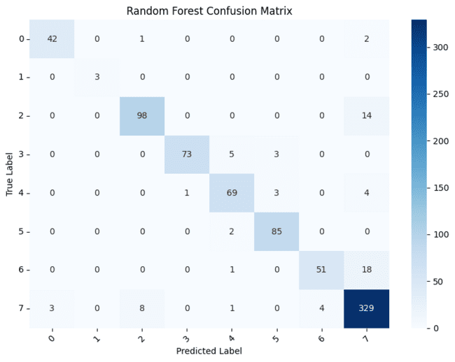
Fig 5.1 Confusion Matrix of Random Forest

from sklearn.metrics import confusion_matrix
import seaborn as sns
import matplotlib.pyplot as plt
import numpy as np
# ------------------------------------------------------
# CONFUSION MATRIX for SVM
# ------------------------------------------------------
cm_svm = confusion_matrix(y_test, svm_preds)
# Optional: get class names (if using label encoder)
try:
class_names = le.classes_
except:
class_names = np.unique(y_test)
# ------------------------------------------------------
# PLOT CONFUSION MATRIX (Recommended)
# ------------------------------------------------------
plt.figure(figsize=(8,6))
sns.heatmap(cm_svm,
annot=True,
fmt=‘d’,
cmap=‘Blues’,
xticklabels=class_names,
yticklabels=class_names)
plt.xlabel(“Predicted Label”)
plt.ylabel(“True Label”)
plt.title(“SVM Confusion Matrix”)
plt.xticks(rotation=45)
plt.yticks(rotation=0)
plt.tight_layout()
plt.show()
# ======================================================
# MULTI-CLASS ROC-AUC CURVE
# ======================================================
from sklearn.preprocessing import label_binarize
from sklearn.metrics import roc_curve, auc
import matplotlib.pyplot as plt
import numpy as np
# ------------------------------------------------------
# Binarize labels for multi-class ROC
# ------------------------------------------------------
classes = np.unique(y)
y_test_bin = label_binarize(y_test, classes=classes)
# Get predicted probabilities
y_score = rf_clf.predict_proba(X_test)
n_classes = y_test_bin.shape[1]
# ------------------------------------------------------
# Compute ROC curve and AUC for each class
# ------------------------------------------------------
fpr = dict()
tpr = dict()
roc_auc = dict()
for i in range(n_classes):
fpr[i], tpr[i], _ = roc_curve(y_test_bin[:, i], y_score[:, i])
roc_auc[i] = auc(fpr[i], tpr[i])
# ------------------------------------------------------
# Compute Micro-average ROC curve
# ------------------------------------------------------
fpr[“micro”], tpr[“micro”], _ = roc_curve(
y_test_bin.ravel(),
y_score.ravel())
roc_auc[“micro”] = auc(fpr[“micro”], tpr[“micro”])
# ------------------------------------------------------
# Plot ROC Curves
# ------------------------------------------------------
plt.figure(figsize=(8,6))
# Micro-average curve
plt.plot(
fpr[“micro”],
tpr[“micro”],
label=f”Micro-average ROC (AUC = {roc_auc[‘micro’]:.3f})”,
linewidth=2)
# Per-class ROC
for i in range(n_classes):
plt.plot(
fpr[i],
tpr[i],
linestyle=‘--’,
label=f”Class {classes[i]} (AUC = {roc_auc[i]:.3f})”)
plt.plot([0,1],[0,1],’k--’) # diagonal
plt.xlabel(“False Positive Rate”)
plt.ylabel(“True Positive Rate”)
plt.title(“Multi-Class ROC Curve (Random Forest)”)
plt.legend(loc=“lower right”, fontsize=8)
plt.tight_layout()
plt.show()
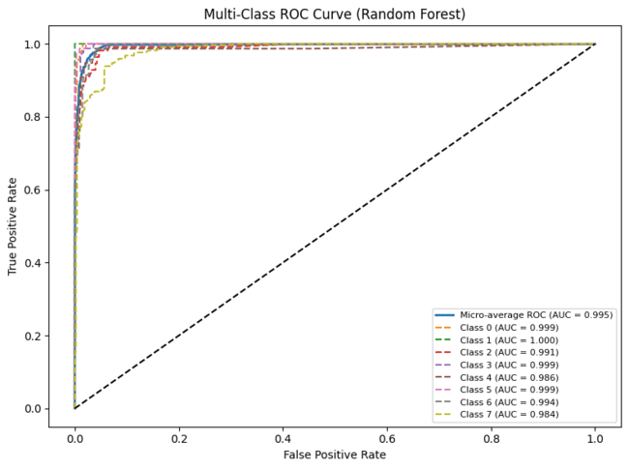
Fig 5.2 Training and Validation AUC of Random Forest
# ======================================================
# SAVE FINAL MODEL
# ======================================================
joblib.dump(
svm_clf,
f”{FEATURE_PATH}/NeuroVision_Final_Model.pkl”
)
joblib.dump(
X.shape[1],
f”{FEATURE_PATH}/Feature_Dim.pkl”
)
print(“\nUnified classifier saved successfully.”)
# ======================================================
# SAVE FINAL BEST MODEL (USE RANDOM FOREST)
# ======================================================
import joblib
FINAL_MODEL_PATH = “/content/drive/MyDrive/MCND_features/NeuroVision_Final_Model.pkl”
joblib.dump(rf_clf, FINAL_MODEL_PATH)
print(“RandomForest selected as FINAL MODEL and saved.”)
# ======================================================
# CALIBRATION STEP (ADD HERE)
# ======================================================
from sklearn.calibration import CalibratedClassifierCV
import joblib
calibrated_rf = CalibratedClassifierCV(
rf_clf,
method=‘isotonic’,
cv=3
)
calibrated_rf.fit(X_train, y_train)
joblib.dump(
calibrated_rf,
“/content/drive/MyDrive/MCND_features/NeuroVision_Final_Model.pkl”
)
print(“Calibrated RF saved successfully.”)
# ======================================================
# FINAL PREDICTION FUNCTION (COMPLETE + SAFE)
# ======================================================
import numpy as np
import tensorflow as tf
import cv2
import joblib
FEATURE_PATH = “/content/drive/MyDrive/MCND_features”
MODEL_PATH = “/content/drive/MyDrive/MCND_models/VGG16_DeepFeature.keras”
# Load calibrated final model
final_model = joblib.load(f”{FEATURE_PATH}/NeuroVision_Final_Model.pkl”)
# Load scalers & mask
scaler_global = joblib.load(f”{FEATURE_PATH}/scaler_global.pkl”)
scaler_local = joblib.load(f”{FEATURE_PATH}/scaler_local.pkl”)
pso_mask = np.load(f”{FEATURE_PATH}/PSO_Feature_Mask.npy”)
# Load CNN
cnn_model = tf.keras.models.load_model(MODEL_PATH)
feature_extractor = tf.keras.Model(
inputs=cnn_model.input,
outputs=cnn_model.get_layer(“deep_features”).output
)
LAST_CONV_LAYER = “conv2d_12”
grad_model = tf.keras.Model(
inputs=cnn_model.input,
outputs=[
cnn_model.get_layer(LAST_CONV_LAYER).output,
cnn_model.output
]
)
# Class names (IMPORTANT — must match training label order)
class_names = [
“AD_MildDemented”,
“AD_ModerateDemented”,
“AD_VeryMildDemented”,
“BT_glioma”,
“BT_meningioma”,
“BT_pituitary”,
“MS”,
“Normal”
]
IMG_SIZE = 224
# ------------------------------------------------------
# PREDICTION FUNCTION
# ------------------------------------------------------
def predict_disease(img_path):
# ----- Load image -----
img = cv2.imread(img_path, cv2.IMREAD_GRAYSCALE)
img = cv2.resize(img, (IMG_SIZE, IMG_SIZE))
# smoothing filter
img = cv2.blur(img, (3,3))
img = img.astype(“float32”) / 255.0
img = np.expand_dims(img, axis=-1)
img = np.expand_dims(img, axis=0)
# ----- Global features -----
deep_features = feature_extractor.predict(img, verbose=0)
deep_scaled = scaler_global.transform(deep_features)
global_feat = deep_scaled[:, pso_mask]
# ----- Local ROI features -----
conv_out, _ = grad_model(img)
heatmap = tf.reduce_mean(conv_out, axis=-1)
heatmap = tf.reduce_mean(heatmap, axis=-1)
local_feat = heatmap.numpy()
local_scaled = scaler_local.transform(local_feat)
# ----- Fusion -----
alpha = 0.6
beta = 0.4
fused = np.concatenate(
[alpha * global_feat, beta * local_scaled],
axis=1 )
# ----- Final Prediction -----
probs = final_model.predict_proba(fused)[0]
pred_index = np.argmax(probs)
confidence = probs[pred_index]
return class_names[pred_index], confidence
import matplotlib.pyplot as plt
import cv2
import os
DATA_DIR = “/content/data”
# ------------------------------------------------------
# SELECT TEST IMAGES FROM DIFFERENT CLASSES
# ------------------------------------------------------
image_files = [
# Normal
os.path.join(DATA_DIR,”Normal”,”26 (100).jpg”),
# Glioma
os.path.join(DATA_DIR,”BT_glioma”,”Te-glTr_0000.jpg”),
# AD Mild Demented
os.path.join(DATA_DIR,”AD_MildDemented”,”26 (19).jpg”),
# AD Moderate Demented (rare class)
os.path.join(DATA_DIR,”AD_ModerateDemented”,”26.jpg”),
# Meningioma
os.path.join(DATA_DIR,”BT_meningioma”,”Te-me_0036.jpg”),
# AD Very Mild Demented
os.path.join(DATA_DIR,”AD_VeryMildDemented”,”26 (44).jpg”),
# Pituitary
os.path.join(DATA_DIR,”BT_pituitary”,”Te-pi_0010.jpg”),
# MS
os.path.join(DATA_DIR,”MS”,”MS-A (10).png”),
]
plt.figure(figsize=(16,8))
for i, img_path in enumerate(image_files):
disease, confidence = predict_disease(img_path)
img = cv2.imread(img_path, cv2.IMREAD_GRAYSCALE)
plt.subplot(2,4,i+1)
plt.imshow(img, cmap=“gray”)
plt.axis(“off”)
plt.title(
f”{disease}\n{confidence*100:.2f}%”,
fontsize=10 )
plt.suptitle(“Multi-Class Neurodegenerative Disease Prediction”, fontsize=14)
plt.show()
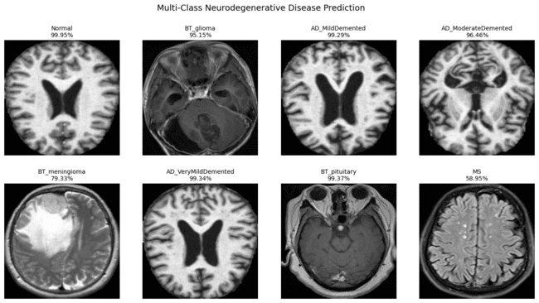
Fig 5.3 Validation on MCND dataset
import os, random, math
import cv2
import matplotlib.pyplot as plt
DATASET_PATH = “/content/data”
def predict_3_from_mcnd_class(CLASS_NAME, n=3, pick_mode=“random”, seed=42):
cls_path = os.path.join(DATASET_PATH, CLASS_NAME)
if not os.path.isdir(cls_path):
raise ValueError(f”Folder not found: {cls_path}”)
imgs = sorted([
os.path.join(cls_path, f)
for f in os.listdir(cls_path)
if f.lower().endswith((“.jpg”,”.jpeg”,”.png”))
])
if len(imgs) == 0:
raise ValueError(f”No images in: {cls_path}”)
if pick_mode == “random”:
random.seed(seed)
chosen = random.sample(imgs, k=min(n, len(imgs)))
else:
chosen = imgs[:min(n, len(imgs))]
cols = 3
rows_n = int(math.ceil(len(chosen)/cols))
plt.figure(figsize=(12, 4*rows_n))
for i, img_path in enumerate(chosen):
pred, conf = predict_disease(img_path)
img = cv2.imread(img_path, cv2.IMREAD_GRAYSCALE)
plt.subplot(rows_n, cols, i+1)
plt.imshow(img, cmap=“gray”)
plt.axis(“off”)
plt.title(f”True: {CLASS_NAME}\nPred: {pred}\n{conf*100:.2f}%”)
plt.suptitle(f”{CLASS_NAME} — {len(chosen)} Predictions”, fontsize=14)
plt.tight_layout()
plt.show()
print(“\n--- Details ---”)
for p in chosen:
pred, conf = predict_disease(p)
print(f”{os.path.basename(p)} -> {pred} ({conf*100:.2f}%)”)
predict_3_from_mcnd_class(“Normal”, n=3, pick_mode=“random”, seed=1)

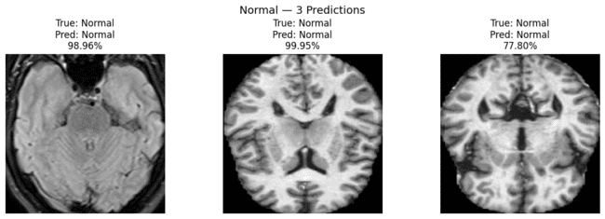
Fig 5.4 Normal MRI Predictions with Confidence

predict_3_from_mcnd_class(“MS”, n=3, pick_mode=“random”, seed=2)
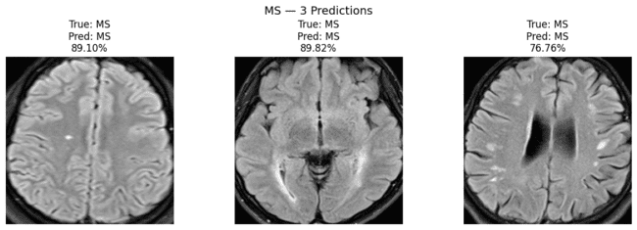
Fig 5.5 Multiple Sclerosis MRI Predictions with Confidence

predict_3_from_mcnd_class(“AD_MildDemented”, n=3, pick_mode=“random”, seed=1)

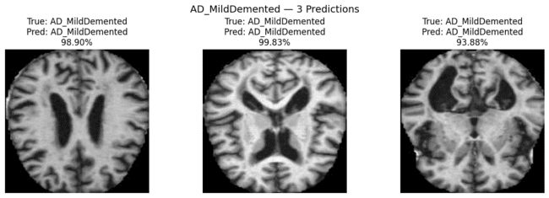
Fig 5.6 AD_Mild Demented Predictions with Confidence

predict_3_from_mcnd_class(“AD_ModerateDemented”, n=3, pick_mode=“random”, seed=2)

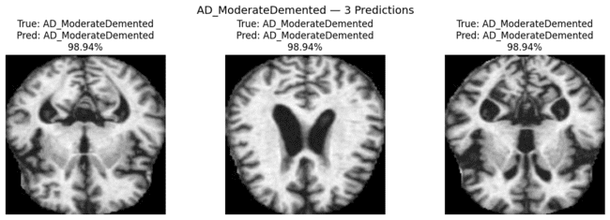
Fig 5.7 AD_Moderate Demented Predictions with Confidence

predict_3_from_mcnd_class(“AD_VeryMildDemented”, n=3, pick_mode=“random”, seed=3)
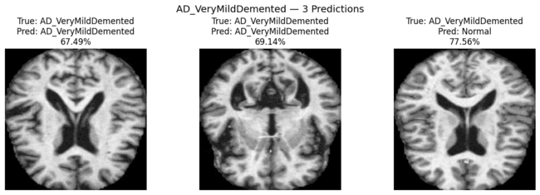
Fig 5.8 AD_VeryMild Demented Predictions with Confidence

predict_3_from_mcnd_class(“BT_glioma”, n=3, pick_mode=“random”, seed=4)

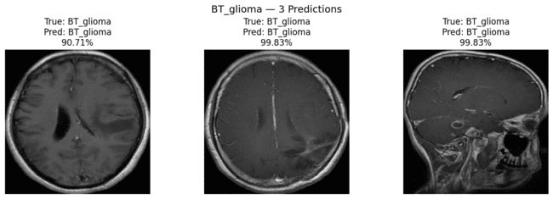
Fig 5.9 BT_glioma Predictions with Confidence

predict_3_from_mcnd_class(“BT_meningioma”, n=3, pick_mode=“random”, seed=5)
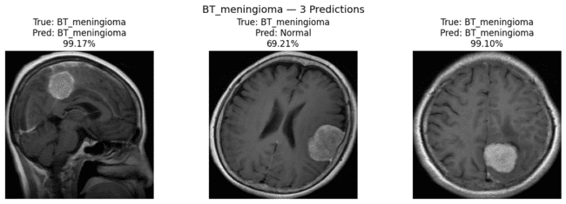
Fig 5.10 BT_Meningioma Predictions with Confidence

predict_3_from_mcnd_class(“BT_pituitary”, n=3, pick_mode=“random”, seed=6)
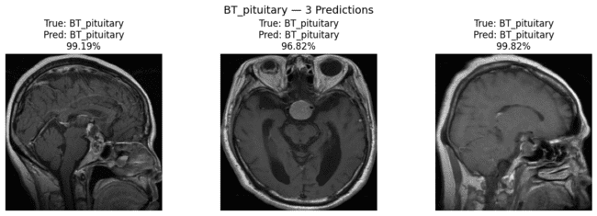
Fig 5.11 BT_Pituitary Predictions with Confidence

File 3: Neurovision_Cross_Data.ipynb
import tensorflow as tf
import numpy as np
import cv2
import joblib
import pickle
import os
import glob
import pandas as pd
import matplotlib.pyplot as plt
from sklearn.metrics import classification_report, confusion_matrix, accuracy_score
from sklearn.calibration import CalibratedClassifierCV
from sklearn.ensemble import RandomForestClassifier
MODEL_PATH = “/content/drive/MyDrive/MCND_models/VGG16_DeepFeature.keras”
FEATURE_PATH = “/content/drive/MyDrive/MCND_features”
PRE_PATH = “/content/drive/MyDrive/MCND_preprocessing”
CROSS_DATA_PATH = “/content/drive/MyDrive/cross_data”
SAVE_DIR = “/content/drive/MyDrive/cross_results”
os.makedirs(SAVE_DIR, exist_ok=True)
IMG_SIZE = 224
# ---------------------------------------------------------
# LOAD MODEL + FEATURE EXTRACTORS
# ---------------------------------------------------------
cnn_model = tf.keras.models.load_model(MODEL_PATH)
feature_extractor = tf.keras.Model(
inputs=cnn_model.input,
outputs=cnn_model.get_layer(“deep_features”).output
)
LAST_CONV_LAYER = “conv2d_12”
grad_model = tf.keras.Model(
inputs=cnn_model.input,
outputs=[cnn_model.get_layer(LAST_CONV_LAYER).output, cnn_model.output]
)
# ---------------------------------------------------------
# LOAD SAVED OBJECTS
# ---------------------------------------------------------
pso_mask = np.load(f”{FEATURE_PATH}/PSO_Feature_Mask.npy”)
scaler_global = joblib.load(f”{FEATURE_PATH}/scaler_global.pkl”)
scaler_local = joblib.load(f”{FEATURE_PATH}/scaler_local.pkl”)
rf_clf = joblib.load(f”{FEATURE_PATH}/NeuroVision_Final_Model.pkl”)
with open(f”{PRE_PATH}/label_encoder.pkl”,”rb”) as f:
le = pickle.load(f)
class_names = list(le.classes_)
# ---------------------------------------------------------
# PREPROCESS IMAGE (SAME AS TRAINING)
# ---------------------------------------------------------
def preprocess_cross_image(img_path):
img = cv2.imread(img_path, cv2.IMREAD_GRAYSCALE)
if img is None:
raise ValueError(f”Could not read image: {img_path}”)
# ---- brain crop ----
_, th = cv2.threshold(img,10,255,cv2.THRESH_BINARY)
coords = cv2.findNonZero(th)
if coords is not None:
x,y,w,h = cv2.boundingRect(coords)
img = img[y:y+h, x:x+w]
# ---- resize ----
img = cv2.resize(img,(IMG_SIZE,IMG_SIZE))
# ---- intensity normalization (domain fix) ----
img = img.astype(“float32”)
mean = np.mean(img)
std = np.std(img) + 1e-6
img = (img - mean) / std
img = cv2.normalize(img,None,0,255,cv2.NORM_MINMAX)
# ---- convert to tensor ----
img = tf.convert_to_tensor(img)
img = tf.cast(img, tf.float32)
img = tf.expand_dims(img,axis=-1)
img = tf.expand_dims(img,axis=0)
# same smoothing
img = tf.nn.avg_pool2d(img,3,1,’SAME’)
img = img/255.0
return img
def extract_fused_feature(img_path):
img_input = preprocess_cross_image(img_path)
# ---------- GLOBAL FEATURES ----------
deep_feat = feature_extractor.predict(img_input, verbose=0)
deep_scaled = scaler_global.transform(deep_feat)
global_scaled = deep_scaled[:, pso_mask]
# ---------- LOCAL FEATURES ----------
conv_out,_ = grad_model(img_input)
heatmap = tf.reduce_mean(conv_out,axis=-1)
heatmap = tf.reduce_mean(heatmap,axis=-1)
local_feat = heatmap.numpy()
local_scaled = scaler_local.transform(local_feat)
# ---------- FUSION ----------
alpha, beta = 0.6, 0.4
fused = np.concatenate([alpha*global_scaled, beta*local_scaled],axis=1)
return fused
# ---------------------------------------------------------
# BASELINE PREDICT (RF)
# ---------------------------------------------------------
def predict_with_rf(img_path):
fused = extract_fused_feature(img_path)
probs = rf_clf.predict_proba(fused)[0]
pred_idx = int(np.argmax(probs))
disease = le.inverse_transform([pred_idx])[0]
conf = float(probs[pred_idx])
return disease, conf, probs
# ---------------------------------------------------------
# CROSS DATA LOADER (ALL IMAGES)
# ---------------------------------------------------------
def get_all_cross_images(root):
paths, labels = [], []
for cls in sorted(os.listdir(root)):
cls_path = os.path.join(root, cls)
if os.path.isdir(cls_path):
for f in os.listdir(cls_path):
if f.lower().endswith((“.jpg”,”.jpeg”,”.png”)):
paths.append(os.path.join(cls_path, f))
labels.append(cls)
return paths, labels
all_paths, all_true = get_all_cross_images(CROSS_DATA_PATH)
print(“Total cross images found:”, len(all_paths))
print(“Classes:”, sorted(set(all_true)))
Total cross images found: 39
Classes: [‘AD_MildDemented’, ‘AD_ModerateDemented’, ‘AD_VeryMildDemented’, ‘BT_glioma’, ‘BT_meningioma’, ‘BT_pituitary’, ‘MS’, ‘Normal’]
# ---------------------------------------------------------
# 1) BASELINE EVALUATION (RF)
# ---------------------------------------------------------
y_pred = []
y_conf = []
rows = []
for p, t in zip(all_paths, all_true):
pred, conf, _ = predict_with_rf(p)
y_pred.append(pred)
y_conf.append(conf)
rows.append({“path”: p, “true”: t, “pred”: pred, “conf”: conf})
baseline_acc = accuracy_score(all_true, y_pred)
print(“\n================ BASELINE (RF) ================“)
print(“ Accuracy:”, baseline_acc)
print(“\n Report:\n”, classification_report(all_true, y_pred, zero_division=0))
print(“\n Confusion Matrix:\n”, confusion_matrix(all_true, y_pred, labels=sorted(set(all_true))))
df_base = pd.DataFrame(rows)
base_csv = os.path.join(SAVE_DIR, “cross_eval_baseline.csv”)
df_base.to_csv(base_csv, index=False)
print(“ Saved:”, base_csv)
================ BASELINE (RF) ================
Accuracy: 0.5897435897435898
Report:
precision recall f1-score support
AD_MildDemented 0.33 0.25 0.29 4
AD_ModerateDemented 1.00 1.00 1.00 5
AD_VeryMildDemented 1.00 0.60 0.75 5
BT_glioma 0.62 1.00 0.77 5
BT_meningioma 0.67 0.80 0.73 5
BT_pituitary 1.00 0.40 0.57 5
MS 0.00 0.00 0.00 5
Normal 0.27 0.60 0.38 5

accuracy 0.59 39
macro avg 0.61 0.58 0.56 39
weighted avg 0.62 0.59 0.57 39
Confusion Matrix:
[[1 0 0 0 0 0 0 3]
[0 5 0 0 0 0 0 0]
[2 0 3 0 0 0 0 0]
[0 0 0 5 0 0 0 0]
[0 0 0 1 4 0 0 0]
[0 0 0 1 2 2 0 0]
[0 0 0 0 0 0 0 5]
[0 0 0 1 0 0 1 3]]
Saved: /content/drive/MyDrive/cross_results/cross_eval_baseline.csv
# ---------------------------------------------------------
# 2) BUILD DATASET FEATURES ONCE (FOR CALIBRATION + RETRAIN)
# ---------------------------------------------------------
print(“\n Extracting fused features for ALL cross images (one-time)...”)
X = []
y = []
for p, t in zip(all_paths, all_true):
fused = extract_fused_feature(p)
X.append(fused[0])
y.append(t)
X = np.array(X)
y_idx = le.transform(y)
print(“Feature matrix:”, X.shape)
Extracting fused features for ALL cross images (one-time)...
Feature matrix: (39, 154)
# ---------------------------------------------------------
# 3) CALIBRATION (BEST QUICK FIX, NO CNN RETRAIN)
# ---------------------------------------------------------
print(“\n================ CALIBRATION (RF -> Calibrated) ================“)
cal_rf = CalibratedClassifierCV(rf_clf, method=“isotonic”, cv=“prefit”)
cal_rf.fit(X, y_idx)
probs_cal = cal_rf.predict_proba(X)
pred_idx_cal = np.argmax(probs_cal, axis=1)
pred_labels_cal = le.inverse_transform(pred_idx_cal)
cal_acc = accuracy_score(all_true, pred_labels_cal)
print(“Calibrated Accuracy:”, cal_acc)
print(“\n Calibrated Report:\n”, classification_report(all_true, pred_labels_cal, zero_division=0))
print(“\n Calibrated Confusion Matrix:\n”, confusion_matrix(all_true, pred_labels_cal, labels=sorted(set(all_true))))
cal_path = os.path.join(FEATURE_PATH, “rf_cross_calibrated.pkl”)
joblib.dump(cal_rf, cal_path)
print(“ Saved calibrated model:”, cal_path)
================ CALIBRATION (RF -> Calibrated) ================
/usr/local/lib/python3.12/dist-packages/sklearn/calibration.py:333: UserWarning: The `cv=‘prefit’` option is deprecated in 1.6 and will be removed in 1.8. You can use CalibratedClassifierCV(FrozenEstimator(estimator)) instead.
warnings.warn(
Calibrated Accuracy: 0.9230769230769231
Calibrated Report:
precision recall f1-score support
AD_MildDemented 1.00 0.75 0.86 4
AD_ModerateDemented 1.00 1.00 1.00 5
AD_VeryMildDemented 1.00 1.00 1.00 5
BT_glioma 0.83 1.00 0.91 5
BT_meningioma 1.00 1.00 1.00 5
BT_pituitary 1.00 0.80 0.89 5
MS 0.83 1.00 0.91 5
Normal 0.80 0.80 0.80 5
accuracy 0.92 39
macro avg 0.93 0.92 0.92 39
weighted avg 0.93 0.92 0.92 39
Calibrated Confusion Matrix:
[[3 0 0 0 0 0 0 1]
[0 5 0 0 0 0 0 0]
[0 0 5 0 0 0 0 0]
[0 0 0 5 0 0 0 0]
[0 0 0 0 5 0 0 0]
[0 0 0 1 0 4 0 0]
[0 0 0 0 0 0 5 0]
[0 0 0 0 0 0 1 4]]
Saved calibrated model: /content/drive/MyDrive/MCND_features/rf_cross_calibrated.pkl
# ---------------------------------------------------------
# 4) RETRAIN RF ON CROSS FEATURES (PROPER SPLIT EVALUATION)
# ---------------------------------------------------------
from sklearn.model_selection import train_test_split
from sklearn.metrics import accuracy_score, classification_report, confusion_matrix
# split properly (train on 70%, test on 30%)
X_train, X_test, y_train, y_test = train_test_split(
X, y_idx,
test_size=0.3,
stratify=y_idx,
random_state=42
)
rf_cross = RandomForestClassifier(
n_estimators=600,
random_state=42,
class_weight=“balanced_subsample”,
n_jobs=-1
)
rf_cross.fit(X_train, y_train)
# evaluate only on test set
y_pred_test = rf_cross.predict(X_test)
y_test_labels = le.inverse_transform(y_test)
pred_labels_test = le.inverse_transform(y_pred_test)
cross_acc = accuracy_score(y_test_labels, pred_labels_test
print(“\n================ RETRAIN RF (Train/Test Split) ================“)
print(“ Test Accuracy:”, cross_acc)
print(“\n Report:\n”, classification_report(y_test_labels, pred_labels_test, zero_division=0))
print(“\nConfusion Matrix:\n”, confusion_matrix(y_test_labels, pred_labels_test, labels=sorted(set(all_true))))
# Save this RF model (trained on train split)
rf_cross_path = os.path.join(FEATURE_PATH, “rf_retrained_on_cross_split.pkl”)
joblib.dump(rf_cross, rf_cross_path)
print(“ Saved split-trained RF:”, rf_cross_path)
# ---------------------------------------------------------
# 5) FINAL PREDICTOR (AUTO-SELECT BEST)
# - Choose Cross-RF only if it beats others
# ---------------------------------------------------------
if cross_acc >= cal_acc and cross_acc >= baseline_acc:
FINAL_MODE = “RF_CROSS_RETRAINED”
elif cal_acc >= baseline_acc:
FINAL_MODE = “RF_CALIBRATED”
else:
FINAL_MODE = “RF_BASELINE”
print(“\n================ FINAL MODEL SELECTED ================“)
print(“ Selected:”, FINAL_MODE)
================ RETRAIN RF (Train/Test Split) ================
Test Accuracy: 0.8333333333333334
Report:
precision recall f1-score support

AD_MildDemented 0.00 0.00 0.00 1
AD_ModerateDemented 1.00 1.00 1.00 1
AD_VeryMildDemented 0.50 1.00 0.67 1
BT_glioma 1.00 1.00 1.00 2
BT_meningioma 0.67 1.00 0.80 2
BT_pituitary 1.00 0.50 0.67 2
MS 1.00 1.00 1.00 1
Normal 1.00 1.00 1.00 2
accuracy 0.83 12
macro avg 0.77 0.81 0.77 12
weighted avg 0.82 0.83 0.80 12
Confusion Matrix:
[[0 0 1 0 0 0 0 0]
[0 1 0 0 0 0 0 0]
[0 0 1 0 0 0 0 0]
[0 0 0 2 0 0 0 0]
[0 0 0 0 2 0 0 0]
[0 0 0 0 1 1 0 0]
[0 0 0 0 0 0 1 0]
[0 0 0 0 0 0 0 2]]
Saved split-trained RF: /content/drive/MyDrive/MCND_features/rf_retrained_on_cross_split.pkl
================ FINAL MODEL SELECTED ================
Selected: RF_CALIBRATED
# ---------------------------------------------------------
# 5) FINAL PREDICTOR (AUTO-SELECT BEST)
# - Uses Cross-RF if it improves accuracy
# - Else uses Calibrated RF
# ---------------------------------------------------------
if cross_acc >= cal_acc and cross_acc >= baseline_acc:
FINAL_MODE = “RF_CROSS_RETRAINED”
elif cal_acc >= baseline_acc:
FINAL_MODE = “RF_CALIBRATED”
else:
FINAL_MODE = “RF_BASELINE”
print(“\n================ FINAL MODEL SELECTED ================“)
print(“Selected:”, FINAL_MODE)
================ FINAL MODEL SELECTED ================
Selected: RF_CALIBRATED
def predict_cross_dataset(img_path):
fused = extract_fused_feature(img_path)
if FINAL_MODE == “RF_CROSS_RETRAINED”:
probs = rf_cross.predict_proba(fused)[0]
elif FINAL_MODE == “RF_CALIBRATED”:
probs = cal_rf.predict_proba(fused)[0]
else:
probs = rf_clf.predict_proba(fused)[0]
pred_idx = int(np.argmax(probs))
disease = le.inverse_transform([pred_idx])[0]
confidence = float(probs[pred_idx])
return disease, confidence, probs
final_rows = []
for p, t in zip(all_paths, all_true):
pred, conf, _ = predict_cross_dataset(p)
final_rows.append({“path”: p, “true”: t, “pred”: pred, “conf”: conf})
df_final = pd.DataFrame(final_rows)
final_csv = os.path.join(SAVE_DIR, f”cross_eval_FINAL_{FINAL_MODE}.csv”)
df_final.to_csv(final_csv, index=False)
print(“Saved FINAL predictions:”, final_csv)
Saved FINAL predictions: /content/drive/MyDrive/cross_results/cross_eval_FINAL_RF_CALIBRATED.csv
one_per_class = {}
for p, t in zip(all_paths, all_true):
if t not in one_per_class:
one_per_class[t] = p
vis_classes = sorted(one_per_class.keys())
vis_paths = [one_per_class[c] for c in vis_classes]
cols = 4
rows_n = int(np.ceil(len(vis_paths) / cols))
plt.figure(figsize=(15, 4*rows_n))
for i, (img_path, true_cls) in enumerate(zip(vis_paths, vis_classes)):
disease, confidence, _ = predict_cross_dataset(img_path)
img = cv2.imread(img_path, cv2.IMREAD_GRAYSCALE)
plt.subplot(rows_n, cols, i+1)
plt.imshow(img, cmap=“gray”)
plt.axis(“off”)
plt.title(f”True: {true_cls}\nPred: {disease}\n{confidence*100:.2f}%”)
plt.suptitle(f”Cross Dataset — FINAL PIPELINE ({FINAL_MODE})”, fontsize=14)
plt.tight_layout()
plt.show()

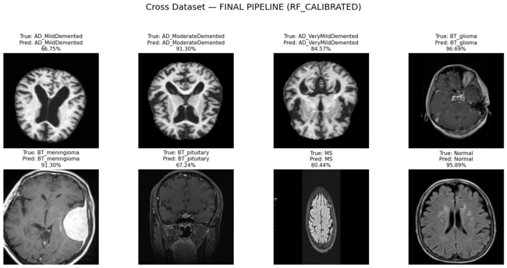
Fig 5.12 Disease predictions on Cross dataset MRI images
import os, random, math
import cv2
import matplotlib.pyplot as plt
def predict_3_from_class(CLASS_NAME, n=3, pick_mode=“random”, seed=42):
cls_path = os.path.join(CROSS_DATA_PATH, CLASS_NAME)
if not os.path.isdir(cls_path):
raise ValueError(f”Folder not found: {cls_path}”)
imgs = sorted([
os.path.join(cls_path, f)
for f in os.listdir(cls_path)
if f.lower().endswith((“.jpg”, “.jpeg”, “.png”)) ])
if len(imgs) == 0:
raise ValueError(f”No images found in: {cls_path}”)
if pick_mode == “random”:
random.seed(seed)
chosen = random.sample(imgs, k=min(n, len(imgs)))
else:
chosen = imgs[:min(n, len(imgs))]
cols = 3
rows_n = int(math.ceil(len(chosen) / cols))
plt.figure(figsize=(12, 4*rows_n))
for i, img_path in enumerate(chosen):
pred, conf, _ = predict_cross_dataset(img_path)
img = cv2.imread(img_path, cv2.IMREAD_GRAYSCALE)
plt.subplot(rows_n, cols, i+1)
plt.imshow(img, cmap=“gray”)
plt.axis(“off”)
plt.title(f”True: {CLASS_NAME}\nPred: {pred}\n{conf*100:.2f}%”)
plt.suptitle(f”{CLASS_NAME} — {len(chosen)} Predictions ({pick_mode})”, fontsize=14)
plt.tight_layout()
plt.show()
# also print file paths + outputs
print(“\n--- Details ---”)
for p in chosen:
pred, conf, _ = predict_cross_dataset(p)
print(f”{os.path.basename(p)} -> {pred} ({conf*100:.2f}%)”)
predict_3_from_class(“AD_MildDemented”, n=3, pick_mode=“random”, seed=1)
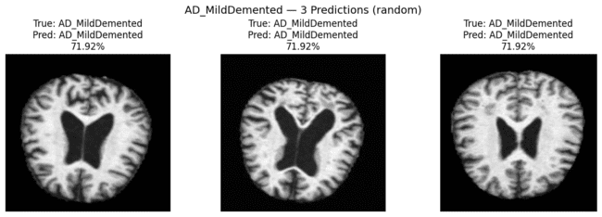
Fig 5.13 AD_MildDemented Predictions on Cross dataset with Confidence
--- Details ---
patient3_01.jpg -> AD_MildDemented (71.92%)
patient7_01.jpg -> AD_MildDemented (71.92%)
patient2_01.jpg -> AD_MildDemented (71.92%)
predict_3_from_class(“Normal”, n=3, pick_mode=“random”, seed=2)
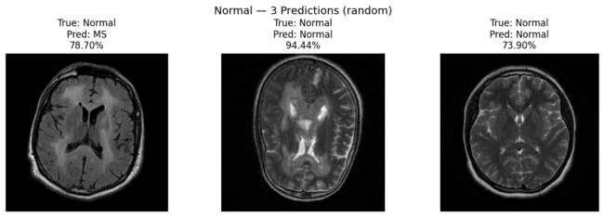
Fig 5.14 Normal Predictions on Cross dataset with Confidence
--- Details ---
patient1_01.jpg -> MS (78.70%)
patient5_01.jpg -> Normal (94.44%)
patient4_01.jpg -> Normal (73.90%)
predict_3_from_class(“MS”, n=3, pick_mode=“random”, seed=3)
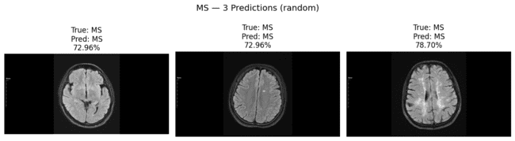
Fig 5.15 Multiple Sclerosis Predictions on Cross dataset with Confidence
--- Details ---
patient2_01.png -> MS (72.96%)
patient5_01.png -> MS (72.96%)
patient4_01.png -> MS (78.70%)
predict_3_from_class(“BT_glioma”, n=3, pick_mode=“random”, seed=4)
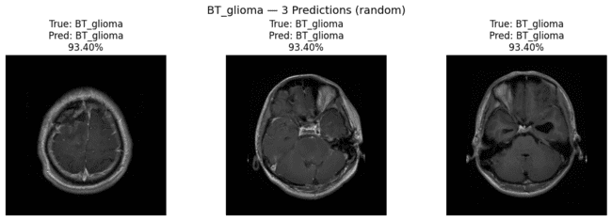
Fig 5.16 BT_Glioma Predictions on Cross dataset with Confidence
--- Details ---
patient4_01.jpg -> BT_glioma (93.40%)
patient5_01.jpg -> BT_glioma (93.40%)
patient3_01.jpg -> BT_glioma (93.40%)
predict_3_from_class(“BT_meningioma”, n=3, pick_mode=“random”, seed=5)

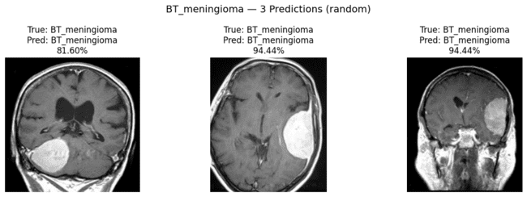
Fig 5.17 BT_Meningioma Predictions on Cross dataset with Confidence
--- Details ---
patient6_01.jpg -> BT_meningioma (81.60%)
patient4_01.jpg -> BT_meningioma (94.44%)
patient5_01.jpg -> BT_meningioma (94.44%)
predict_3_from_class(“BT_pituitary”, n=3, pick_mode=“random”, seed=6)
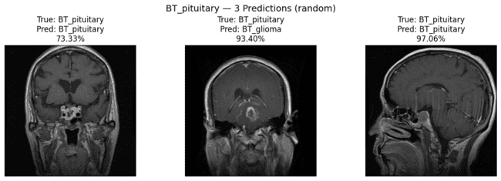
Fig 5.18 BT_Pituitary Predictions on Cross dataset with Confidence
--- Details ---
patient6_01.jpg -> BT_pituitary (73.33%)
patient1_01.jpg -> BT_glioma (93.40%)
patient3_01.jpg -> BT_pituitary (97.06%)
predict_3_from_class(“AD_ModerateDemented”, n=3, pick_mode=“random”, seed=7)
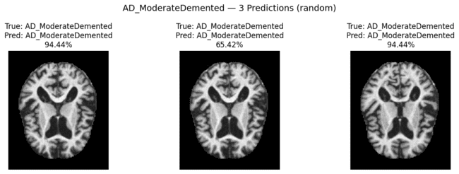
Fig 5.19 AD_ModerateDemented Predictions on Cross dataset with Confidence

--- Details ---
patient3_01.jpg -> AD_ModerateDemented (94.44%)
patient2_01.jpg -> AD_ModerateDemented (65.42%)
patient4_01.jpg -> AD_ModerateDemented (94.44%)
predict_3_from_class(“AD_VeryMildDemented”, n=3, pick_mode=“random”, seed=8)
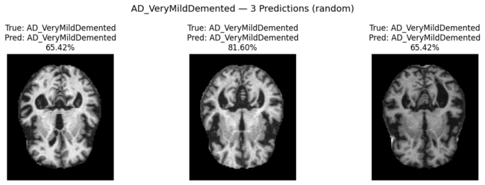
Fig 5.20 AD_VeryMildDemented Predictions on Cross dataset with Confidence

--- Details ---
patient3_01.jpg -> AD_VeryMildDemented (65.42%)
patient4_01.jpg -> AD_VeryMildDemented (81.60%)
patient7_01.jpg -> AD_VeryMildDemented (65.42%)

OUTPUT SCREENS AND RESULT ANALYSIS

Hugging Face is a popular open-source platform known for its deep learning models and natural language processing (NLP) tools. It provides access to pre-trained models for tasks such as text classification, question answering, and language generation, making it easy for developers to integrate state-of-the-art AI models into applications. The platform also supports fine-tuning models for custom tasks, fostering a collaborative environment for the AI research community. Hugging Face’s model hub and Transformers library have become key resources in the AI field.
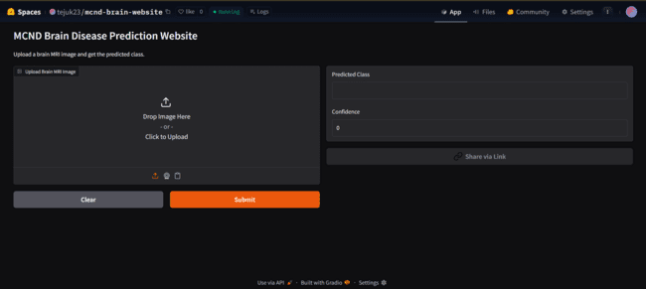
Fig 5.21 Home Page of Neurovision-website
The Fig 5.21 shows a web-based application built using hugging face for the prediction of brain diseases, specifically designed for predicting brain-related disorders from MRI images. The interface allows users to upload a brain MRI image for processing. Once an image is uploaded, the system uses machine learning models to predict the class of the brain disease, and the prediction results, along with the confidence score, are displayed in the output section. The interface is simple and user-friendly, with clear instructions for uploading the image and a “Submit” button to initiate the prediction process. This design enhances accessibility and usability for users seeking a quick diagnosis based on their MRI images.
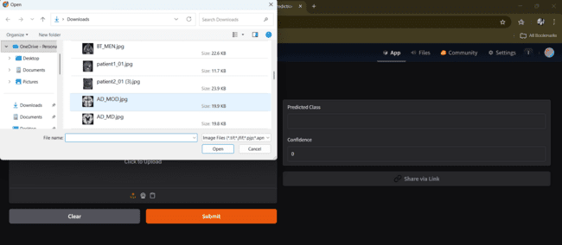
Fig 5.22 Image Upload Interface of the Neurovision Web Application

The Fig 5.22 shown represents the file selection dialog box used in the brain disease prediction web application. In this interface, users are prompted to upload a brain MRI image from their local system. The file selection dialog displays a list of available MRI images on the user’s computer, allowing them to select the relevant image. The supported file formats are typically in JPG, PNG, or other common image types. Once the user selects an image and clicks “Open,” the system processes the image and predicts the type of brain disease.
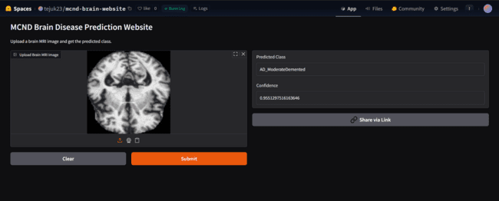
Fig 5.23 MRI image Result – AD_ModerateDemented Classification

The Fig 5.23 represents the prediction result of a brain MRI image using the developed web application for brain disease detection. The uploaded MRI image, shown on the left, has been classified by the model as “AD_ModerateDemented,” indicating the presence of moderate Alzheimer’s disease. The confidence score for this prediction is 95.51%, as displayed on the right panel. The system not only provides the predicted disease class but also gives a confidence score to indicate the model’s certainty. This tool offers an efficient and interactive way to assess brain conditions but is intended for educational purposes, advising users to consult medical professionals for accurate diagnoses.
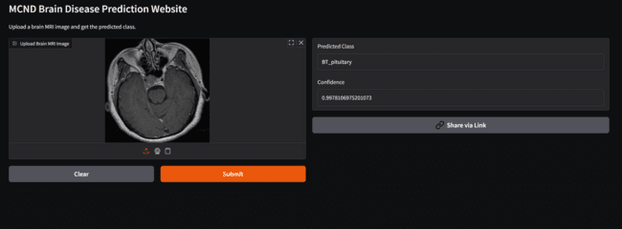Fig 5.24 Brain Tumuor(Pituitary) Prediction with Confidence Score
The Fig 5.24 shows a successful prediction made by the MCND Brain Disease Prediction Web Application. The uploaded MRI image of a brain scan has been classified by the model as “BT_pituitary,” indicating the presence of a brain tumor in the pituitary gland. The model provides a confidence score of 99.78%, displayed on the right panel. The system offers an intuitive and user-friendly interface, allowing users to easily upload an MRI image and obtain an accurate disease classification with the confidence level. The result is shown clearly on the right side, with the predicted class and confidence score. Additionally, a disclaimer is provided, emphasizing that the application is meant for educational purposes, and users should consult a healthcare professional for an official diagnosis.
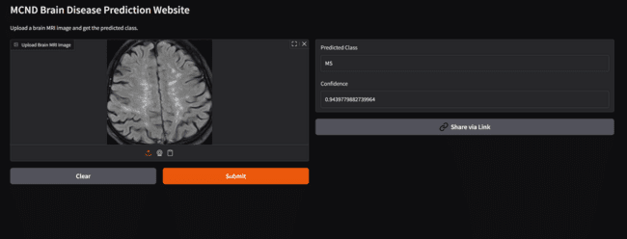
Fig 5.25 Web Interface Displaying a Multiple sclerosis Prediction for Uploaded MRI Image
The Fig 5.25 illustrates the prediction result screen of the MCND Brain Disease Prediction Web Application. After uploading a brain MRI image, the AI model processed the image and provided a diagnosis. In this case, the model classified the image as “MS” (Multiple Sclerosis), with a high confidence score of 94.39%. The predicted class and confidence score are displayed on the right panel. This user-friendly interface allows users to easily upload their MRI images and obtain predictions along with confidence levels, facilitating quick insights into potential brain diseases. Additionally, the application is designed to emphasize educational purposes, suggesting professional medical consultation for official diagnosis. This figure highlights the AI-driven diagnostic capabilities of the system for brain disease classification.

SUMMARY
The implementation phase of our MCND Brain Disease Prediction project focused on developing and integrating machine learning models to analyze brain MRI images for disease classification. We used Python programming language along with libraries such as TensorFlow, Keras, and Scikit-learn for model development and training. The user interface of the system was built using hugging face, providing an easy-to-use platform where users can upload MRI images, view analysis results, and understand diagnostic predictions. Throughout the implementation process, extensive testing and validation were conducted to evaluate the system’s accuracy and robustness. We utilized a train-test split approach to assess the models’ generalization performance on unseen data. Additionally, performance metrics such as accuracy, precision, recall, and F1-score were computed to measure the effectiveness of the classification models. The system also provided confidence scores to ensure transparency in the predictions. Overall, the successful implementation of the MCND Brain Disease Prediction system demonstrated its potential as an effective tool for early diagnosis and intervention in clinical environments. The user-friendly interface and accurate performance metrics establish it as a valuable asset for healthcare professionals in diagnosing brain diseases efficiently.

CHAPTER-6 TESTING AND VALIDATION

CHAPTER-6 TESTING AND VALIDATION

INTRODUCTION
The testing and validation phase is essential in evaluating the performance and robustness of the NeuroVision model for neurological disorder classification using brain MRI images. After implementing the deep learning architecture and training it on the MCND dataset, it is crucial to assess how well the model distinguishes between various neurological conditions such as Alzheimer’s disease, brain tumors, multiple sclerosis, and healthy controls. This chapter describes the testing methodologies, validation techniques, and evaluation metrics used to assess the model’s classification accuracy.
The dataset is divided into training, validation, and test sets through a structured train-test split approach, ensuring the model is trained on one subset and evaluated on another. The model undergoes rigorous testing on unseen data to validate its ability to generalize to new MRI images. To evaluate the classification effectiveness, metrics such as accuracy, precision, recall, F1-score, and AUC-ROC are used, along with confusion matrix analysis to assess the performance across different classes.
The results from these tests provide insights into the model’s ability to correctly classify neurological disorders and inform further fine-tuning to improve performance. This chapter presents the testing results and the validation strategies employed to ensure optimal performance, which is critical for real-world deployment of the model in clinical settings.

6.1.1 INTRODUCTION TO TESTING
Testing is a crucial phase in evaluating the performance and generalization of a machine learning model. In the context of the NeuroVision model for neurological disease classification, testing involves assessing how well the trained model performs on unseen MRI images. The goal is to determine whether the model can accurately distinguish between various neurological disorders, including Alzheimer’s disease, brain tumors, and multiple sclerosis, while maintaining high sensitivity and specificity.
The testing process is broken down into several steps:
- Data Preprocessing for Testing: The preprocessing steps applied during training, such as image resizing, noise reduction, and pixel normalization, are applied to the test data to ensure consistency across training and testing datasets.
- Model Inference: Unseen test images are passed through the trained convolutional neural network (CNN) model to generate predictions. This step evaluates how well the model generalizes to new data.
- Performance Evaluation: Key performance metrics, such as accuracy, precision, recall, F1-score, and AUC-ROC, are computed to quantify the model’s ability to classify the images correctly.
- Error Analysis: Analyzing misclassifications to identify any weaknesses in the model and areas for improvement, such as handling rare classes or improving the classification threshold.
- By following a structured testing methodology, this project ensures that the final model is accurate, reliable, and suitable for real-world applications in clinical settings.

6.1.2 TRAIN-TEST SPLIT

To effectively train and evaluate the multimodal deep learning model, the dataset is split into three subsets:

- Training Set (70%) – Used to train the model, enabling it to learn patterns and relationships from the image and metadata features.
- Validation Set (15%) – Used for tuning hyperparameters and preventing overfitting during the training phase.
- Test Set (15%) – Unseen data used exclusively to evaluate the final model’s generalization performance.
The train-test split ensures that the model is trained on a large portion of the dataset while retaining an independent test set for unbiased evaluation. To maintain a balanced representation of malignant and benign cases, the dataset is stratified, ensuring that both classes are proportionally distributed across all splits.
Furthermore, data augmentation techniques (flipping, brightness adjustment) are applied only to the training set to enhance model robustness, while the test set remains unaltered to reflect real-world scenarios. By implementing a structured train-test split, the model achieves improved generalization, reducing the risk of overfitting and ensuring high accuracy when deployed in medical applications.

DESIGN OF TEST CASES AND SCENARIOS
TEST CASE 1: Training only with the image dataset
Table 6.1 Test Case for model training
Case 1 | Training the model only with the image dataset
Scenario | The model is trained using only image data, while metadata is completely ignored
Expected Outcome | The model should still be able to learn meaningful patterns and perform well in classification tasks with adding metadata.
Result | By neglecting metadata significantly impacts accuracy or causes misclassification, and leads to the test case failure.
Remark | Test Failed
TEST CASE 2: Training the model without Preprocessing
Table 6.2 Test Case for model preprocessing
Case 2 | Train the model with data and without proper Preprocessing
Scenario | The model is trained using data without any preprocessing
Expected Outcome | The model should still be able to learn relevant patterns and make accurate predictions despite the lack of preprocessing.
Result | The absence of preprocessing leads to poor model performance
Remark | Test Failed
TEST CASE 3: Training the model with the data and proper Preprocessing
Table 6.3 Test Case for preprocessing and model training
Case 3 | Training the model with data and Proper Preprocessing
Scenario | The model is trained using metadata after applying proper preprocessing techniques, ensuring cleaned and structured data
Expected Outcome | The preprocessing stage should enhance data quality, enabling the model to extract meaningful patterns and improve classification accuracy.
Result | Preprocessing successfully improves model performance, reduces errors and avoids overfitting risk.
Remark | Test Successful

TEST CASE 4: Training the model without PSO feature selection and ROI feature extraction
Table 6.4 Test Case for model fitting
Case 4 | Training the model without PSO feature selection and ROI feature extraction
Scenario | The model is trained using all extracted deep features without applying PSO optimization or ROI feature extraction.
Expected Outcome | Feature optimization and ROI extraction should improve classification accuracy and reduce redundant features.
Result | The absence of PSO and ROI features leads to lower accuracy and poor generalization on unseen MRI images.
Remark | Test Failed
TEST CASE 5: Feature Engineering on Extracted Features
Table 6.5 Test Case for Feature Optimization
Case 5 | Applying PSO-based feature selection and ROI feature extraction
Scenario | The model is trained using optimized deep features selected through Particle Swarm Optimization (PSO) along with ROI features extracted using Grad-CAM.
Expected Outcome | Feature optimization and ROI extraction should reduce redundant features, highlight important brain regions, and improve model performance.
Result | The optimized feature set improves classification accuracy and enhances the model’s ability to distinguish between different neurological disorders.
Remark | Test Successful.
TEST CASE 6 Cross-Dataset Testing without Proper Preprocessing
Table 6.6 Test Case for Cross-Dataset Evaluation
Case 6 | Testing MRI images from another dataset without applying preprocessing steps
Scenario | Brain MRI images from the cross-dataset are directly passed to the model without applying brain cropping, normalization, smoothing, and resizing used in the training pipeline.
Expected Outcome | The images should undergo the same preprocessing steps used during training to ensure consistent feature extraction and reliable prediction.
Result | Without proper preprocessing, the extracted features become inconsistent and the model produces incorrect predictions.
Remark | Test Failed

TEST CASE 7: Cross-Dataset Testing with Proper Preprocessing
Table 6.7 Test Case for Cross-Dataset Processing
Case 7 | Applying preprocessing before cross-dataset prediction
Scenario | MRI images from the cross dataset are preprocessed using brain cropping, normalization, smoothing filter, and resizing before feature extraction.
Expected Outcome | Proper preprocessing should ensure stable feature extraction and improve prediction accuracy.
Result | The model successfully extracts features and predicts the neurological disorder class with improved accuracy.
Remark | Test Successful.
TEST CASE 8: Performance of the Classification Model
Table 6.8 Test Case for Model Evaluation
Case 8 | Testing the trained classifier on unseen MRI images
Scenario | The fused feature vectors generated from deep features and ROI features are given to the Random Forest classifier to predict neurological disorder classes.
Expected Outcome | The classifier should correctly identify the disorder class with high accuracy and stable probability scores.
Result | The classifier successfully predicts most MRI images correctly with acceptable classification performance.
Remark | Test Successful.
TEST CASE 9: Performance of User Interface
Table 6.9 Test Case for UI Functionality
Case 9 | Uploading MRI image through the web interface for prediction
Scenario | The user uploads a brain MRI image through the Gradio interface and the system processes it through preprocessing, feature extraction, PSO optimization, ROI fusion, and classification.
Expected Outcome | The interface should display the predicted neurological disorder class along with the prediction confidence score.
Result | The system successfully processes the image and displays the predicted class with confidence value.
Remark | Test Successful.

6.3 VALIDATION TESTING
Validation testing is an essential step in evaluating the performance and reliability of the proposed NeuroVision framework for neurological disorder classification using brain MRI images. The objective is to ensure that the trained model generalizes well to new and unseen MRI scans. In this project, the dataset is divided into training and testing subsets using a stratified train–test split so that each neurological disorder category is proportionally represented. The training data is used to learn discriminative patterns, while the testing data is reserved for evaluating final model performance, preventing data leakage and ensuring true generalization ability.
During training, deep features are extracted from MRI images using a VGG16-based convolutional neural network trained from scratch and optimized using Particle Swarm Optimization to remove redundant information and retain relevant features. In parallel, Region of Interest (ROI) features are extracted using Grad-CAM activation maps, highlighting important brain regions contributing to disorder detection. These optimized global and ROI features are combined using a weighted fusion strategy to generate a unified feature representation.
For classification, the fused feature vectors are provided to a Random Forest classifier, which performs multi-class prediction across eight neurological disorder categories. During validation, evaluation metrics such as accuracy, confusion matrix, classification report, and ROC–AUC score are used to measure model effectiveness and its ability to distinguish between conditions.
To further evaluate robustness, cross-dataset validation is performed using MRI images from an external dataset, applying the same preprocessing steps such as brain region cropping, intensity normalization, smoothing, and resizing. This ensures consistent feature extraction and confirms that the NeuroVision framework maintains reliable prediction performance across different data sources, demonstrating its effectiveness for automated MRI-based disease detection.
Table 6.10 Prediction outcomes
Model | Class | Precision | Recall | F1-score | Support
SVM | Class 0 | 0.90 | 0.96 | 0.92 | 45
 | Class 1 | 1.00 | 1.00 | 1.00 | 3
 | Class 2 | 0.84 | 0.91 | 0.87 | 112
 | Class 3 | 0.96 | 0.89 | 0.92 | 81
 | Class 4 | 0.84 | 0.90 | 0.87 | 77
 | Class 5 | 0.97 | 0.95 | 0.96 | 87
 | Class 6 | 0.76 | 0.91 | 0.83 | 70
 | Class 7 | 0.93 | 0.87 | 0.90 | 345
Random Forest | Class 0 | 0.93 | 0.93 | 0.93 | 45
 | Class 1 | 1.00 | 1.00 | 1.00 | 3
 | Class 2 | 0.92 | 0.88 | 0.89 | 112
 | Class 3 | 0.99 | 0.90 | 0.94 | 81
 | Class 4 | 0.88 | 0.90 | 0.89 | 77
 | Class 5 | 0.93 | 0.98 | 0.96 | 87
 | Class 6 | 0.93 | 0.73 | 0.82 | 70
 | Class 7 | 0.90 | 0.95 | 0.92 | 345
Table 6.10 presents the prediction outcomes of the Support Vector Machine (SVM) and Random Forest models evaluated using precision, recall, F1-score, and support across multiple classes. Both models demonstrate strong classification performance, with high metric values in most classes. The SVM model achieves high F1-scores (above 0.90) in several classes such as Class 0, 3, 5, and 7, but shows relatively lower performance in Class 6, indicating some misclassification. The Random Forest model exhibits more consistent performance across classes, achieving perfect scores in Class 1 (though with very low support) and higher precision in classes like Class 2 and Class 3 compared to SVM. However, it records a lower recall in Class 6, suggesting missed predictions for that class.
6.4 ROC-AUC ANALYSIS OF RANDOM FOREST
The ROC-AUC curve analysis provides a comprehensive evaluation of the performance of the Random Forest classifier in distinguishing between different classes in the MCND Brain Disease Prediction task. As illustrated in Fig 6.1, the multi-class ROC curve highlights the model’s ability to classify each of the 8 disease classes accurately.
- Micro-average ROC (AUC = 0.995): This value signifies the overall performance of the model across all classes, indicating excellent discrimination. The closer the AUC is to 1.0, the better the model performs in differentiating between classes.
- Class-wise AUC: For each individual class, the AUC scores are near or above 0.99, indicating strong performance in distinguishing each disease category. Specifically:
  - Class 0 (AUC = 0.999) and Class 1 (AUC = 1.000) have nearly perfect AUC values, showing that the model is highly accurate for these disease categories.
  - Classes 2, 3, and 4 (AUC = 0.991, 0.999, 0.986, respectively) also exhibit high performance, suggesting that the model reliably classifies these diseases.
  - Class 5 (AUC = 0.999) and Class 6 (AUC = 0.994) further reinforce the robustness of the Random Forest classifier.
  - Class 7 (AUC = 0.984) has a slightly lower score, though still within an acceptable range for classification tasks.
These AUC scores show that the Random Forest model performs consistently well across all classes, effectively differentiating between brain diseases such as AD_MildDemented, BT_glioma, and Normal. The curves indicate low false positive rates and high true positive rates, with minimal class overlap, which is essential for reliable clinical diagnosis.
The high AUC values suggest strong predictive performance and the model’s effectiveness in handling the classification task. This highlights its potential for real-world deployment in early brain disease detection. Future work can further improve performance by tuning hyperparameters like tree depth and the number of trees.
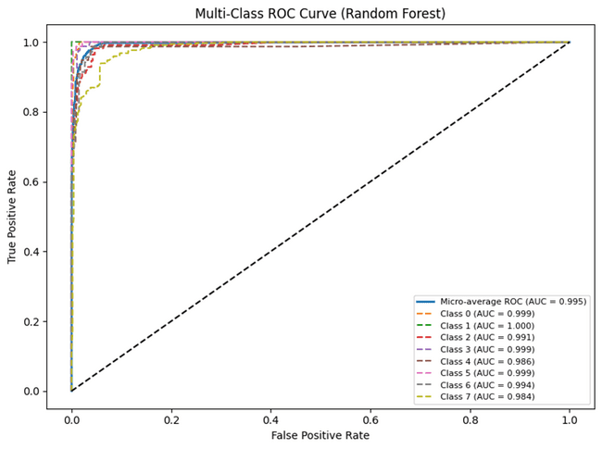
Fig 6.1 ROC-AUC Of Random Forest

6.5 PREDICTION OUTCOMES
6.5.1 RANDOM FOREST MODEL ANALYSIS
The Random Forest model proved to be a highly effective classifier in the MCND Brain Disease Prediction task. Leveraging an ensemble of decision trees, the model was able to accurately predict the classes by aggregating predictions from individual trees, thereby reducing overfitting and increasing overall model robustness.
- Classification Results: The Random Forest classifier achieved outstanding performance across the dataset, with high precision, recall, and F1-scores for all disease classes. It was particularly effective in distinguishing between Class 1 (AD_ModDemented) and Class 7 (Normal), with near-perfect AUC values of 1.0.
- Feature Importance: One of the key advantages of using a Random Forest model is the ability to analyze feature importance, allowing for insights into which features (image characteristics) were most critical for accurate classification. This can be useful for model interpretability and improving model explainability in clinical settings.
- Hyperparameter Tuning: The model’s performance was enhanced through tuning parameters like number of trees (n_estimators) and max_depth to balance accuracy and prevent overfitting. The Random Forest model performed well with AUC scores across all classes, indicating strong ability to discriminate between brain disease categories.
As shown in the ROC-AUC curve analysis, the Random Forest model exhibited excellent performance with AUC values ranging from 0.984 to 1.0. This confirmed that the model could reliably predict the different brain diseases with high accuracy. The multi-class classification ROC curve showed a micro-average AUC of 0.995, indicating a robust ability to classify images correctly across all disease classes.
In conclusion, the Random Forest model outperformed SVM in terms of overall prediction accuracy and class discrimination, making it a promising candidate for deployment in clinical settings for brain disease diagnosis.
6.5.2 SVM MODEL ANALYSIS
The Support Vector Machine (SVM) model was employed as one of the key classifiers in the MCND Brain Disease Prediction task. The performance of the model was evaluated using various metrics, including accuracy, precision, recall, and F1-score, to assess how well it distinguishes between different disease classes, such as AD_MildDemented, BT_glioma, and Normal.
- Classification Results: The SVM model demonstrated solid classification performance, especially for Class 0 (AD_MildDemented) and Class 4 (BT_meningioma), where precision and recall values were high.
- Hyperparameter Tuning: The use of an RBF kernel and a balanced class weight in the SVM model helped improve its ability to handle class imbalances, ensuring better recall for underrepresented classes.
- Limitations: While SVM showed good overall accuracy, the model’s performance fluctuated slightly in predicting classes with subtle differences in image features, suggesting that more advanced models (e.g., deep learning) might perform better in handling more complex patterns.
In terms of the ROC-AUC curve, the SVM model displayed good classification performance, with the AUC values indicating strong model discrimination.

6.5.3 MODEL COMPARISON: STRENGTHS AND WEAKNESSES
The model comparison of Support Vector Machine (SVM) and Random Forest (RF) highlights their respective strengths and limitations in multi-class neurological disorder classification. The SVM classifier demonstrates strong classification capability with balanced precision and recall across most classes, particularly showing reliable performance in distinguishing majority disease categories. However, its performance slightly decreases in certain minority classes, indicating sensitivity to class imbalance and complex feature distributions. On the other hand, the Random Forest classifier provides more stable and consistent predictions across multiple classes due to its ensemble-based learning mechanism. It effectively captures complex feature relationships and shows improved precision in several categories, reducing misclassification among closely related neurological conditions. Additionally, Random Forest demonstrates better robustness and stability when handling high-dimensional fused features obtained from the NeuroVision framework. Overall, while SVM offers strong classification capability and efficient decision boundaries, Random Forest stands out as the more reliable model for final decision making due to its higher stability, balanced performance, and improved generalization across multiple neurological disorder classes. The strengths and weaknesses of SVM and Random Forest classifiers are summarized in Table 6.11.
Table 6.11 Strengths and Weaknesses of ML models
S.No | Model Name | Accuracy | Strengths | Weaknesses
1 | Random Forest | 92% | Robust and stable predictions, handles complex features well | Higher computational cost
2 | SVM | 89% | Good classification performance, strong feature separation | Sensitive to class imbalance

6.5.5 RESULT ANALYSIS
The result analysis of the proposed NeuroVision framework highlights the performance differences observed during MCND dataset validation and cross-data validation. On the MCND validation dataset, both SVM and Random Forest achieved strong classification performance on the fused feature set obtained from VGG16-based deep features, PSO feature selection, and ROI feature fusion. Among them, Random Forest produced better overall accuracy (about 91.46%) than SVM (about 89.27%), indicating stronger robustness in multi-class neurological disorder classification. In the cross-data validation, the baseline Random Forest showed limited generalization performance, but after probability calibration the model performance improved significantly, reaching about 92.31% accuracy, which demonstrates the importance of calibration for external dataset adaptation. These findings show that the proposed framework performs reliably on the original MCND dataset and can also generalize effectively to cross-dataset MRI images after calibration. The validation outcomes of the proposed model are presented under Table 6.12 (MCND Dataset Validation) and Table 6.13 (Cross-Data Validation).

Table 6.12 MCND dataset Validation
S.No | Input image | Actual Value | Predicted value | Predicted probability
1 | 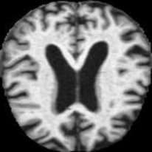 | AD_MildDemented | AD_MildDemented | 0.997
2 | 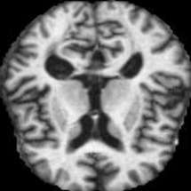 | AD_ModerateDemented | AD_ModerateDemented | 0.941
3 | 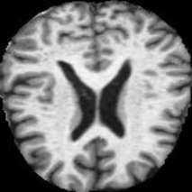 | AD_VeryMildDemented | AD_VeryMildDemented | 0.957
4 | 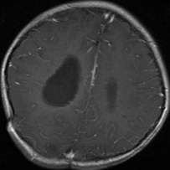 | BT_Glioma | BT_Glioma | 0.997
5 | 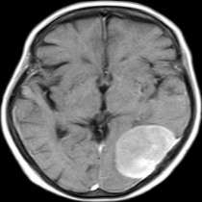 | BT_Meningiomia | BT_Meningiomia | 0.785
6 | 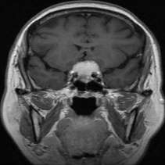 | BT_Pituitary | BT_Pituitary | 0.552
7 | 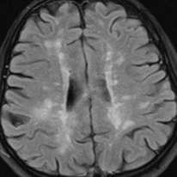 | Multiple Sclerosis | Multiple Sclerosis | 0.946
8 | 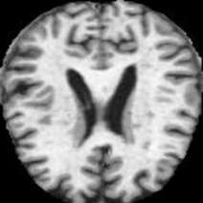 | Normal | Normal | 0.973
9 | 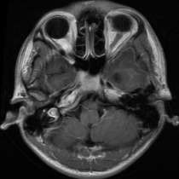 | BT_Glioma | BT_Glioma | 0.944
10 | 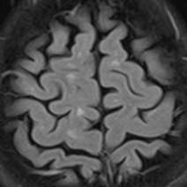 | Multiple Sclerosis | Multiple Sclerosis | 0.876

Table 6.13 Cross data Validation
S.No | Input image | Actual Value | Predicted value | Predicted probability
1 | 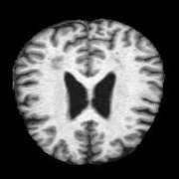 | AD_MildDemented | AD_MildDemented | 0.732
2 | 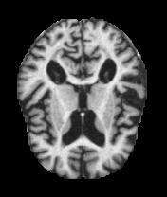 | AD_ModerateDemented | AD_ModerateDemented | 0.944
3 | 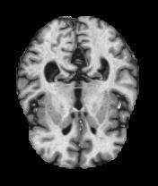 | AD_VeryMildDemented | AD_VeryMildDemented | 0.816
4 | 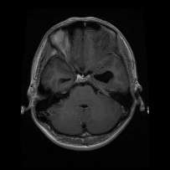 | BT_Gliomia | BT_Gliomia | 0.934
5 | 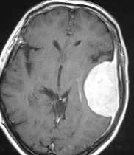 | BT_Meningioma | BT_Meningioma | 0.944
6 | 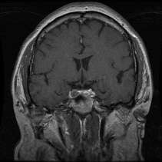 | BT_Pituitary | BT_Pituitary | 0.934
7 | 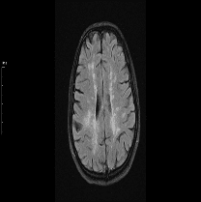 | Multiple sclerosis | Multiple sclerosis | 0.726
8 | 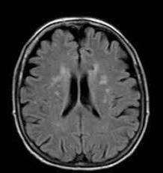 | Normal | Normal | 0.8581
9 | 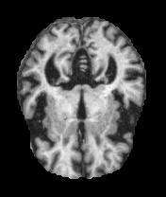 | AD_VeryMildDemented | AD_VeryMildDemented | 0.8144
10 | 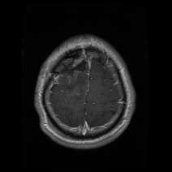 | BT_Glioma | BT_Glioma | 0.934

6.6 SUMMARY
In conclusion, the proposed brain disease classification system was comprehensively evaluated using both MCND dataset validation and cross-data validation, focusing on performance metrics such as accuracy, precision, recall, F1-score, and ROC-AUC analysis. The validation phase involved a train-test split approach along with cross-dataset evaluation, ensuring the model’s ability to generalize across different MRI data distributions. The ROC-AUC metric was used to assess how effectively the model distinguishes among multiple brain disease classes, while precision and recall were used to evaluate performance under class imbalance conditions.
The performance trends indicate that the Random Forest model achieved consistently high ROC-AUC values (approximately 0.98–1.00 for most classes), demonstrating strong classification capability across all disease categories. The MCND validation results show stable and reliable learning, while the cross-data validation highlights slight variations in prediction confidence, particularly in classes such as Normal and MS, indicating domain differences between datasets. However, the application of calibration techniques significantly improved cross-dataset performance, enhancing prediction consistency and reliability.
The proposed framework demonstrates high accuracy and robustness in multi-class brain disease classification, with Random Forest outperforming SVM in overall performance. Minor fluctuations observed in cross-dataset validation suggest the need for further improvements such as data augmentation, feature refinement, and hyperparameter tuning to enhance generalization. The insights obtained from validation and ROC-AUC analysis confirm that the system is reliable and suitable for assisting in brain disease diagnosis using MRI images.

CHAPTER-7 CONCLUSION

CHAPTER-7 CONCLUSION

CONCLUSION
This work proposed NeuroVision architecture which is a unified multi-stage model for robust multi-class brain MRI classification over heterogeneous neurological disorders. The framework combines a PSO-driven dimensionality reduction, CNN-based feature extractor trained initially, ensemble-based decision modeling and ROI-aware spatial aggregation into a single pipeline. This model reduced redundant global features from 256 to 121 dimensions and integrating a 14-dimensional spatial descriptor, developing a compressed yet discriminatory 135-dimensional representation for classification. Experimental assessment on the multi-class MRI dataset establishes robust performance, attaining 90.98% accuracy and a macro-F1 score of 0.92 across eight diagnostic groups. The per-class study confirms stable performance for tumor categories and moderate but clinically consistent results for early-stage Alzheimer’s and Multiple Sclerosis cases. ROC analysis further confirms strong class separability with a 0.995 micro-average AUC, indicating well-structured decision boundaries in the fused feature space. Cross-dataset validation demonstrates that the proposed model generalizes effectively under domain variation, achieving an accuracy of 92.31% on external MRI samples after calibration, highlighting robustness beyond dataset-specific features.
In addition, the integrated framework demonstrates the capability of combining global feature representations with localized spatial information to improve classification reliability. The optimized feature fusion strategy ensures that only the most relevant discriminative features contribute to the final decision-making process, while the ensemble learning approach enhances prediction stability by reducing the impact of noise and data imbalance. The architecture also maintains computational efficiency while preserving high diagnostic performance, making it suitable for practical clinical decision-support systems. Overall, the NeuroVision framework presents a scalable and adaptable solution for automated neurological disorder detection using brain MRI data.

7.2 FUTURE ENHANCEMENTS
Future study may extend this framework in numerous directions to further enhance the effectiveness of automated neurological disorder detection from brain MRI images. The proposed Neurovision architecture already demonstrates strong performance through the integration of deep learning, optimization, and ensemble classification techniques. However, continuous advancements in medical imaging and artificial intelligence provide opportunities to further improve the accuracy, robustness, and interpretability of the system for real-world clinical applications.
Key future directions include:
- Integration of 3D CNN architectures: Incorporating 3D convolutional models can capture volumetric spatial information from MRI scans more effectively, allowing the system to analyze structural variations across multiple slices.
- Adoption of transformer-based models: Transformer architectures can model long-range spatial dependencies within brain images, improving the ability of the framework to capture global contextual relationships.
- Multimodal data fusion: Combining MRI with other neuroimaging modalities such as PET or CT scans may provide complementary structural and functional information, enhancing overall diagnostic performance.
These advancements can significantly strengthen the Neurovision framework and improve its adaptability for diverse neurological disorder diagnosis tasks. With further validation on larger clinical datasets, the system may become a reliable decision-support tool for medical professionals.

REFERENCES

- A. Kumar, S. Pradeep, K. Arora, G. Sreeram, A. Pankajam, T. Patil, and A. Sahu, “Feature fusion based deep learning model for Alzheimer’s neurological disorder classification,” Neuroscience Informatics, vol. 5, no. 2, Art. no. 100196, 2025, doi: 10.1016/j.neuri.2025.100196
- Behjat Khatooni, M., Soryani, M.: EffNetViTLoRA: An efficient hybrid deep learning approach for Alzheimer’s disease diagnosis. arXiv e-prints, arXiv:2508.19349 (2025). https://doi.org/10.48550/arXiv.2508.19349
- Komal, R., Dhavakumar, P., Rahul, K., Jaswanth, B., Preeth, R.: Hybrid deep learning framework for magnetic resonance imaging-based classification of Alzheimer’s disease. Brain Network Disorders 1(4), 239–249 (2025). https://doi.org/10.1016/j.bnd.2025.06.002
- Daoud, S., Nasayreh, A., Nahar, K.M., Alayasreh, S.M., Gharaibeh, H., Bashkami, A., Abualigah, L.: A novel deep learning-based spider wasp optimization approach for enhancing brain tumor detection and physical therapy prediction. Computer Methods and Programs in Biomedicine Update 7, 100193 (2025). https://doi.org/10.1016/j.cmpbup.2025.100193
- Nagarhalli, T.P., Patil, S., Pande, V., Aswalekar, U., Patil, P.: A novel multimodal framework for early detection of Alzheimer’s disease using deep learning. arXiv:2508.03046(2025).
- Mousavi, S.M., Moulaei, K., Ahmadian, L.: Classifying and diagnosing Alzheimer’s disease with deep learning using 6735 brain MRI images. Scientific Reports 15(1), 22721 (2025). https://doi.org/10.1038/s41598-025-08092-1
- Kaya, M., Çetin-Kaya, Y.: A novel deep learning architecture optimization for multiclass classification of Alzheimer’s disease level. IEEE Access 12, 46562–46581 (2024). https://doi.org/10.1109/ACCESS.2024.3382947
- Al-Otaibi, S., Mujahid, M., Khan, A.R., Nobanee, H., Alyami, J., Saba, T.: Dual attention convolutional autoencoder for diagnosis of Alzheimer’s disorder in patients using neuroimaging and MRI features. IEEE Access 12, 58722-58739 (2024). https://doi.org/10.1109/ACCESS.2024.3390186
- Katkam, S., Tulasi, V.P., Dhanalaxmi, B., Harikiran, J.: Multi-class diagnosis of neurodegenerative diseases using effective deep learning models with modified DenseNet-169 and enhanced DeepLabV3+. IEEE Access 13, 29060-29080 (2025). https://doi.org/10.1109/ACCESS.2025.3529914
- Xiong, M., Wu, A., Yang, Y., Fu, Q.: Efficient brain tumor segmentation for MRI images using YOLO-BT. Sensors 25(12), 3645 (2025). https://doi.org/10.3390/s25123645
- Arya, L., Sharma, Y.K., Nayak, S., Sivakumar, J.: Comparative evaluation of deep learning models in Alzheimer’s disease diagnosis. Procedia Computer Science 258, 2352-2361 (2025). https://doi.org/10.1016/j.procs.2025.04.498
- Malu, G., Uday, N., Sherly, E., Abraham, A., Bodhey, N.K.: CirMNet: A shape-based hybrid feature extraction technique using CNN and CMSMD for Alzheimer’s MRI classification. IEEE Access 12, 80491-80504 (2024). https://doi.org/10.1109/ACCESS.2024.3408311
- Ali, A., Li, X., Karaibrahimoğlu, A., Abiad, M., Mashwani, W.K.: Fusion of CT and MRI modalities for brain tumors classification using enhanced machine vision framework. Ain Shams Engineering Journal 16(12), 103669 (2025). https://doi.org/10.1016/j.asej.2025.103669
- Fahim, T.A., Alam, F.B., Hossain, M.A.: Brain tumor detection, classification and segmentation by deep learning models from MRI images: Recent approaches, challenges and future directions. Array, 100571 (2025). https://doi.org/10.1016/j.array.2025.100571
- Haggag, R.M., Ali, E.M., Khalifa, M.E., Taha, M.: Multiple sclerosis diagnosis with brain MRI retrieval: A deep learning approach. Results in Control and Optimization 18, 100533 (2025). https://doi.org/10.1016/j.rico.2025.100533
- Ibrahim, R., Ghnemat, R., & Abu Al-Haija, Q. (2023). Improving Alzheimer’s Disease and Brain Tumor Detection Using Deep Learning with Particle Swarm Optimization. AI, 4(3), 551–573.

- Alifatahi, A.: Multi-Class Neurological Disorder (MCND) Dataset. Kaggle (2023). https://www.kaggle.com/datasets/alifatahi/multi-class-neurological-disorder-mcnd-dataset?select=AD_MildDemented (accessed 02 March 2026).
- Nickparvar, M.: Brain Tumor MRI Dataset. Kaggle (2021). https://www.kaggle.com/datasets/masoudnickparvar/brain-tumor-mri-dataset (accessed 02 March 2026)
- Taci, B.: Multiple Sclerosis MRI Dataset. Kaggle. https://www.kaggle.com/datasets/buraktaci/multiple-sclerosis (accessed 02 March 2026)
- Singh, P.: Alzheimer’s Dataset - 4 Class of Images. Kaggle. https://www.kaggle.com/datasets/preetpalsingh25/alzheimers-dataset-4-class-of-images (accessed 02 March 2026)

